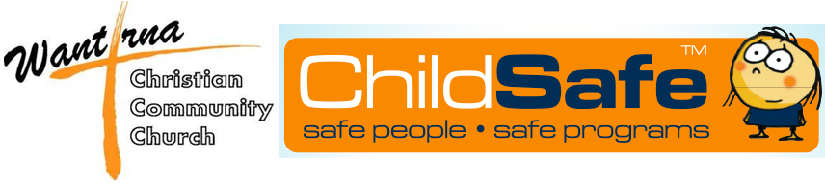 | General Safety and Care Checklist  Resource Code CSE2-SM

A list of factors to consider is presented to assist you in providing for the safety and care of your participants. References are provided in brackets to relevant materials within the ChildSafe System. ‘TM Guide’ refers to the Team Members Pocket Guide.

- Participation
Yes No | Team Members have been briefed to ensure that participation in activities is voluntary for everyone.
Yes No | Team Members have been trained to ensure sensitivity is shown in relation to issues of gender, ethnicity, family and medical conditions. [TM Guide B2]

- Leadership [TM Guide B4]
Yes No | All activities have a Team Member assigned to supervise them.
Yes No | The program has an appropriate ratio of Team Members to participants.
Yes No | The Team Members have adequate experience in the activities offered.
Yes No | The team consists of people who are appropriate for their leadership role.

- Duty of Care [TM Guide B2 & B3]
Yes No | Procedures are in place to ensure adequate care at all times.
Yes No | Specifically, group control mechanisms are in place to minimise the chance of somebody getting lost.
Yes No | Thought has been given to the process of locating somebody who has become lost and leaders briefed.
Yes No | Consent has been obtained from caregivers in relation to potentially risky activities.
Yes No | The team has been appropriately trained in relation to physical contact, children at risk of harm, disclosure of abuse and related issues.

4. Equipment and the Site
Yes No | The site is suitable for the program.
Yes No | The equipment is suitable for the program, and has been checked prior to use.
Yes No | Where permission is required for use of a venue, it has been obtained.

5. First Aid and Medical Care [TM Guide C5]
Yes No | Medical forms for all involved are completed appropriately and stored in a secure location in case they are required.
Yes No | The amount of first aid equipment, type and condition of equipment and the required number of separate first aid kits has been considered and provided for.
Yes No | Appropriate precautions are being taken to minimise health risks during the program.

6. Transport [TM Guide C3]
Yes No | Drivers hold appropriate licences.
Yes No | Inexperienced drivers have been informed that they are excluded from driving participants.
Yes No | Team Members are appropriately briefed on the requirement for seat belts or safety restraints.
Yes No | Vehicles are appropriately registered, in roadworthy condition and appropriately insured.
Yes No | Drivers are aware that vehicle insurance is their responsibility.

7. Additional factors to consider
Yes No | Team Members are aware of your organisation’s policies in relation to alcohol and substance use.
Yes No | Team Members are aware of the basics of insurance arrangements provided by your organisation.
Yes No | Team Members have been briefed about what to do in the event that the Media wish to interview somebody in relation to your program.
Yes No | In residential programs, accommodation arrangements are generally single sex, other than for adult couples sleeping in their own location.
Yes No | Copies of all appropriate forms have been provided to the organisation.

