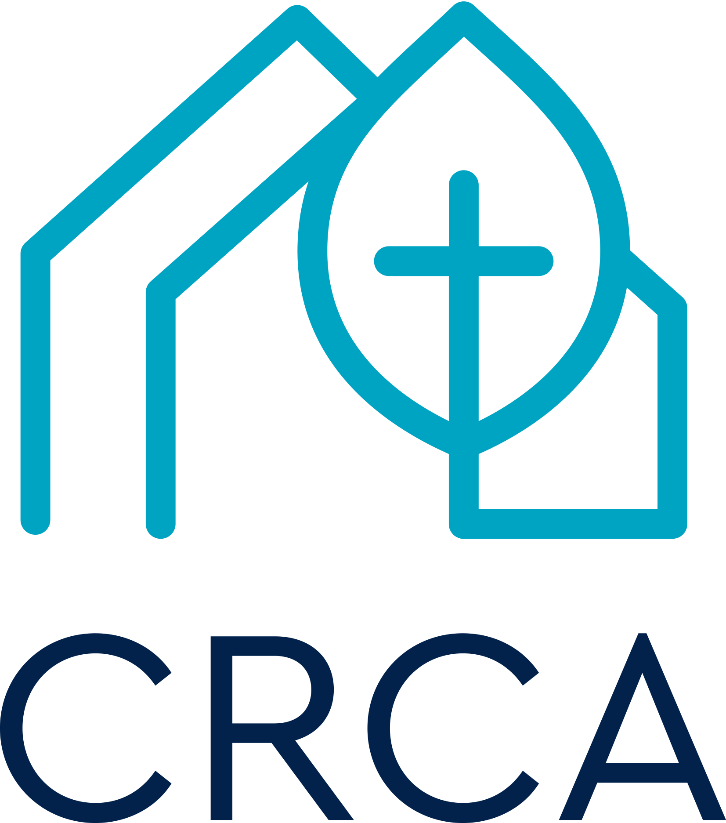 | Complaint & Abuse Reporting Form  Resource Code CSE3-IRC

When should this report be completed?
This report must be completed if:
- There is an alleged illegal act, a participant sent home, serious leader dispute, damage or loss of property.
- The situation relates to Child Protection (disclosure of abuse, allegation of abuse, or report based on reasonable grounds).
- You have a grievance about anything relating to the activities or buildings/physical environment of the church.
- Other situations will require judgement and consultation with your organisation. In situations where doubt exists about the use of this report, complete a report.

What do I do with this report after I have completed it?
- Check that all information is correct to the best of your knowledge.
- Check that the appropriate signatures are given.
- The Team Leader forwards the form to your Coordinator as soon as possible. More severe complaints require immediate reporting, while other reports should be submitted within seven days.

SECTION A
Nature of the Event/Complaint/Abuse
Please describe the event in a one sentence summary.

When and where did this event occur?
Time of Event (specify AM/PM) |  |  | Date
Location Name
Exact Place

Name of the program
Team Leader
Surname |  | Given Names

SECTION B - details of people involved in the event (including witnesses - attach signed and dated reports of witnesses if applicable)

Person 1 (Details of person subject of the complaint)
Surname (Capitals) |  |  |  |  |  |  |  | Given Names
Street Address
Suburb |  |  |  |  | Postcode |  |  |  | Sex | M F |  |  | Date of Birth
Phone | home |  |  |  |  | work |  |  |  |  |  | mobile

Person 2 (any possible witnesses)
Surname (Capitals) |  |  |  |  |  |  |  | Given Names
Street Address
Suburb |  |  |  |  | Postcode |  |  |  | Sex | M F |  |  | Date of Birth
Phone | home |  |  |  |  | work |  |  |  |  |  | mobile

Attach an additional page or pages if details for additional people are relevant.

SECTION C Use this section for Child Protection Issues
Refer to the ChildSafe SP3 Team Members Guide for information in relation to abuse, disclosure, allegation or belief based on reasonable grounds.
Ensure that you understand the reporting requirements and process in your jurisdiction.

In relation to disclosure by a child, attach details of what was said by the child to this report. In relation to allegations or belief based on reasonable grounds, ensure that relevant sections of this report are completed, and attach notes to the report that carefully provide factual details and/or describe how you have arrived at the belief that a child is at risk of harm.

Please enter details: Attach report if insufficient space

What action has been taken? Remember to be specific, noting the timings. Attach report if insufficient space

Complaint Form Completion
Signatures
Complainant Name: | _________________ | Complainant Signature: |  | Date:
Supervising Team Member Name: |  | Supervising Team Member Signature: |  | Date:
Team Leader Name: |  | Team Leader Signature : |  | Date:

Please submit this report as soon as possible. Reports dealing with issues of a greater level of severity must be submitted immediately, and all reports within seven days of the event. Thank you for your assistance.

Office Use Only - Complaint Follow-up Plan
Possible  action | Report filed  & registered | Medical  form filed | Other docs  (incl. photos  filed | Insurer  notified | Parental  follow-up | Team Leader  follow-up | Coordinator  follow-up | Event entered in SMO (Safety Management Online)
Required
Initials
Date

