 | Incident Report  Resource Code CSE4-IR

When should this report be completed?
This report must be completed if:
- An outside emergency service is contacted (Police, Ambulance, State Emergency Service etc.).
- An individual is taken to hospital, doctor’s surgery, emergency dental surgery, or other medical professional.
- An injury results in a participant being unable to participate for 24 hours.
- There is an alleged illegal act, a participant sent home, serious leader dispute, damage or loss of property.
- The situation relates to Child Protection (disclosure of abuse, allegation of abuse, or report based on reasonable grounds).
- Other situations will require judgement and consultation with your organisation. In situations where doubt exists about the use of this report, complete a report.
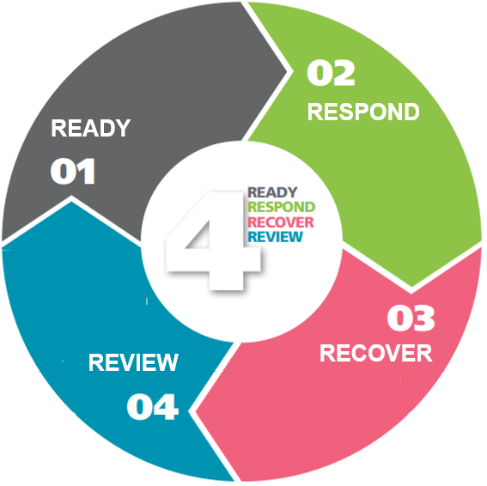

How do I complete this report?
- Sections A and B must be completed in all situations, and
- Section C and E are to be completed where there is an injury to an individual.
- Section D and F are to be completed in relation to Child abuse issues.

What do I do with this report after I have completed it?
- Check that all information is correct to the best of your knowledge.
- Check that the appropriate signatures are given.
- The Team Leader forwards the form to your Coordinator as soon as possible. More severe incidents require immediate reporting, while other reports should be submitted within seven days.

Section A: Nature of the Event
Please describe the event in a one sentence summary.

When and where did this event occur?
Time of Event (specify AM/PM) |  |  |  |  |  | Date:
Location Name:
Exact Place:

Name of the program
Did this event have ‘Permission to Proceed’? |  |  |  | ◻ Yes | ◻ No
Team Leader
Surname: |  | Given Names:

Section B: People involved in the event (including witnesses - attach signed and dated reports of witnesses if applicable)

Person 1 (Details of injured person if applicable - remember to fill in Section C)
Surname (Capitals): |  |  |  |  |  |  |  | Given Names:
Street Address:
Suburb: |  |  |  |  | Postcode: |  |  |  | Sex: | ◻ M ◻ F ◻ O |  |  | Date of Birth:
Phone: | home |  |  |  |  | work |  |  |  |  |  | mobile

Person 2:
Surname (Capitals): |  |  |  |  |  |  |  | Given Names:
Street Address:
Suburb: |  |  |  |  | Postcode: |  |  |  | Sex: | ◻ M ◻ F ◻ O |  |  | Date of Birth:
Phone: | home |  |  |  |  | work |  |  |  |  |  | mobile

Attach an additional page or pages if details for additional people are relevant.

Section C: Injury details ( to be completed only if the event involved injury. Circle the relevant responses)

The injured person was a Participant / Team Member / Other (please specify): ________________________________________

Initial Severity Assessment
First Aid (stayed at program) / First Aid (sent home) / Medical Treatment at Hospital / Possible Permanent Disability / Fatal

Part of body injured -Doctor appointment for body parts marked *
Eye * / Ear / Nose / Mouth / Face / Jaws* / Neck* / Skull* / Head - Other* / Shoulder / Elbow / Wrist / Hand / Finger /
Arm – Other / Groin / Hip / Knee / Ankle / Foot / Toe / Leg / Chest / Torso – Other / Internal / Back* / Nervous System / Skin / Respiratory System / Systemic
Other (please specify): _________________________________

Nature of Injury
Superficial / Fracture / Strain-Sprain / Irritation / Hernia / Bruise or Crush / Bite or Sting / Hearing Loss / Laceration or Cut / Poisoning / Infection / Disease / Amputation / Concussion / Allergy / Burn or Scald
Other (please specify):_________________________________

Cause of Severest Injury
Slip or Fall / Aquatic Activity / Burns / Vehicle Accident / Person related / Sporting /
Other (please specify): _______________________________

Immediate Treatment: Remember, note the times and be as detailed as possible in the action that was taken to care for the casualty. (Give details. Attach additional notes if required.)

Doctor
Surname (Capitals): |  |  |  |  |  | Given Names
Street Address:
Suburb: |  |  |  | Postcode: |  |  | Phone | work

Hospital
Name:
Street Address:
Suburb: |  |  |  | Postcode: |  | Suburb:

Was the activity supervised? | ◻ Yes | ◻ No

Personal Data of Supervising Team Member
Surname (Capitals): |  |  |  |  |  |  |  |  |  | Given Names:
Street Address:
Suburb: |  |  |  |  |  | Postcode: |  |  |  |  | Sex: | ◻ M ◻ F ◻ O |  |  | Date of Birth:
Phone: | home |  |  |  |  |  | Work: |  |  |  |  |  |  | Mobile:

Please describe the injured person's training and experience related to the activity at the time of the accident - attach report if insufficient space.

Protective Equipment/Safety Devices:
Were protective equipment/safety devices related to this activity being used? If Yes, please give details- attach report if insufficient space. | ◻ Yes | ◻ No | ◻ Not applicable
Pre-Existing Condition
Does the injured person suffer from any pre-existing condition which may have caused or aggravated the injury?  If Yes, please give details- attach report if insufficient space. | ◻ Yes | ◻ No

Section D: Child Harm and Abuse Incident. Circle the relevant abuse definition below.

Such allegations or disclosures may not relate directly to your organisation’s event at all but occur on it as a disclosure.
The organisation complaint and abuse disclosure procedure should be followed accordingly including reporting to authorities as required.

The injured person was a Participant / Team Member / Other (please specify, maintain appropriate confidentiality):

Initial Abuse Assessment (Circle relevant abuse as defined by State authorities, ChildSafe training and guides, and/or your policy).
Physical Abuse / Emotional or Psychological Abuse / Neglect / Sexual Abuse / Family Violence / Bullying

Factual Description of the event (what happened): State in clear terms exactly what is understood to have happened.

Section E: Injury assessment and follow up (to Section C)
Were any pertinent instructions/warnings given before the event? | ◻ Yes | ◻ No
If Yes, please give details - attach report if insufficient space.

Factual Description of the event (what happened): State exactly what is understood to have happened, how the incident has occurred, the nature of the event, who was claimed to be involved, and times. Identify who has made the observations. Record facts, not assumptions. Attach report if insufficient space.

What action has been taken? Remember to be specific, noting the timings. Attach report if insufficient space.

What follow-up, in your view, needs to occur and by whom?

Has other action been taken as appropriate?
Parent/Guardian notified? |  | ◻ Yes |  | ◻ No
Photographs of Event Site? |  | ◻ Yes |  | ◻ No
Police Notified? | ◻ Yes |  | ◻ No |  | If Yes, police report number:
If any other organisations have been advised, please state details:

Section F: Abuse assessment and follow up (to Section D)
Use this section for Child Abuse and Child Protection Issues. Consult your organisation complaint and abuse disclosure procedure including understanding your reporting requirements in your State. Also refer your ChildSafe Team Members Guide, Chapters 6 & 7, for definitions and information in relation to abuse, disclosures, allegation and an objective decision to report based on ‘reasonable belief’.
In relation to disclosure by a child, attach the specific words used by the child to this report. In relation to allegations or belief based on ‘reasonable belief’, ensure that relevant sections of this report are completed, and attach notes to the report that carefully provide factual details and/or describe how you have arrived at ‘reasonable belief’ that a child is at risk of harm.

What action has been taken? Remember to be specific, noting the timings. Attach report if insufficient space.

Police Notified? | ◻ Yes | ◻ No | Date: ___ ___ _____ |  | If Yes, police report number
Child Protection Services Notified? | ◻ Yes | ◻ No | Date: ___ ___ _____
Reportable Conduct Notified? | ◻ Yes | ◻ No | Date: ___ ___ _____ | ◻ Not applicable
Internal Reportable Notified? | ◻ Yes | ◻ No | Date: ___ ___ _____

Section G: Incident report completion and sign off

Supervising Team Member Name: |  | Supervising Team Member Signature: |  | Date:
Team Leader Name: |  | Team Leader Signature: |  | Date:

Please submit this report as soon as possible. Reports dealing with issues of a greater level of severity must be submitted immediately, and all reports within seven days of the event. Thank you for your assistance.
Office Use Only - Incident Follow-up Plan
Possible  action | Report filed & registered | Medical  form filed | Other docs  (incl. photos  filed | Insurer  notified | Parental  follow-up | Team Leader  follow-up | Coordinator  follow-up | Event entered on  Incident summary and overview sheet e.g. CSE4-OI
Required
Initials
Date

