 | Application Form Template  Resource Code CSE4-OA

Volunteer Application Form
CONFIDENTIAL
This form must be completed by all applicants for voluntary work with

________________

The information requested will:
- provide an insight into the applicant’s experience, skills, abilities and resources.
- highlight an applicant’s responsibilities as
a leader.
- remain confidential.

On completion, please
forward this form to

________________

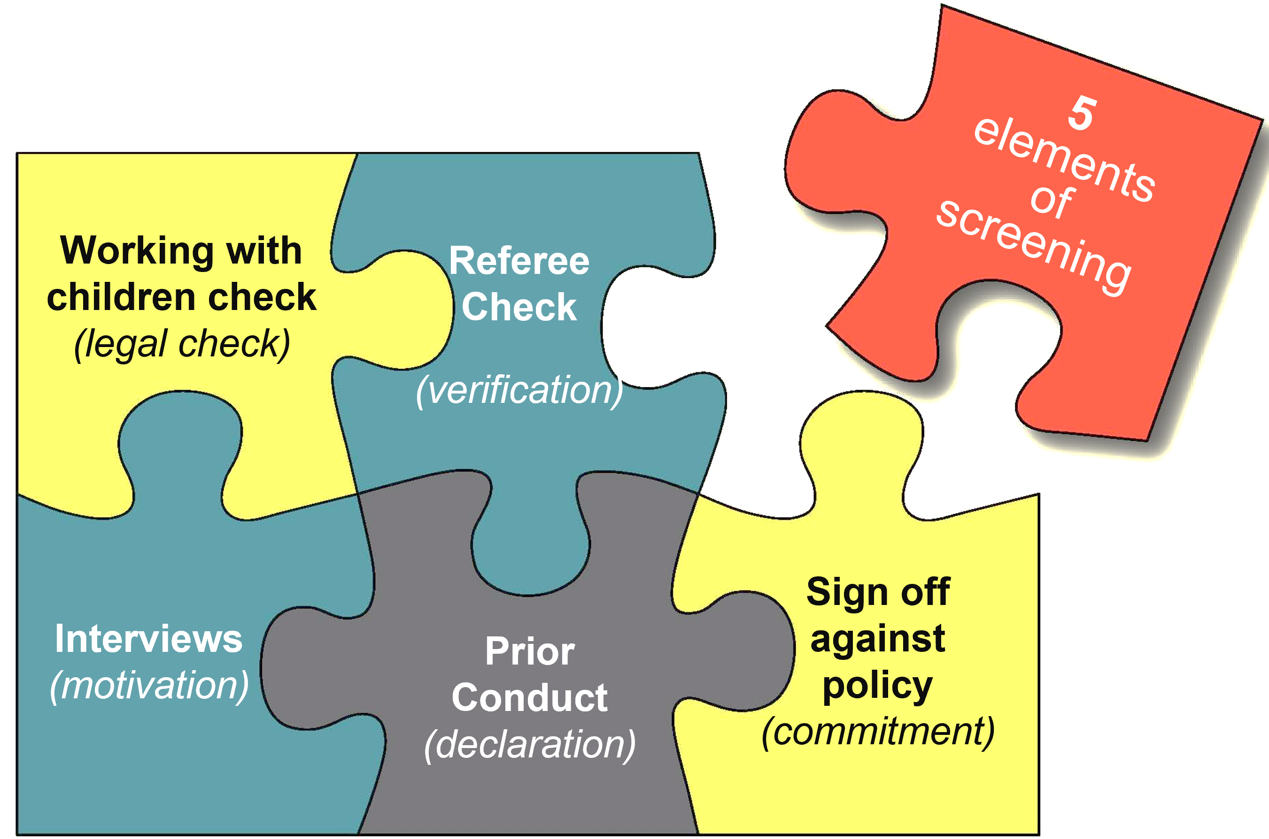

I am applying to be a volunteer for:
________________________________________________

My Team Leader

________________

PERSONAL DETAILS
Name in full (Please print clearly): _________________________________________________________________
Mr / Mrs / Ms / Miss _________________________ M F O
Preferred Name: ___________________________________ DOB _____ / _____ / ________
Occupation: _______________________________________
Home Address: _______________________________________________________________
_______________________________________________ Postcode: ____________
Postal Address: _______________________________________________________________
_______________________________________________ Postcode: ____________
Phone (H): ____________________ (W): ____________________ .(M): _________________
Email: (Please print clearly): _____________________________________

EMERGENCY CONTACT DETAILS

Name: ________________________________________________ Relationship: ___________________
Address: _______________________________________________________________
_______________________________________________ Postcode: ____________
Phone (H): ____________________ (W): ____________________ .(M): _________________

REFEREES: Before your application can be approved, please give details of two people who have agreed to be your referees. Neither should be a family member.

Contact details #1: Contact details #2:
Name: __________________________________ Name: __________________________________
Address: _________________________________ Address: ________________________________
____________________________ P/C: _________ ____________________________ P/C: ________
(H): ______________________________________ (H): ______________________________________
(M): ______________________________________ (M): ______________________________________

OFFICE USE ONLY: Review Date _____ / _____ / 20_____
References Checked: 1____________ 2____________ WWC check: __________________ Interview: _________________ logged in SMO (if applicable)
Appointment Authority: Name____________________ Signature _____________________ Date _____ / _____ / 202___

PLEASE TELL US ABOUT YOURSELF (or use broader question set as required)

1. Please outline your reasons for offering to work with children, young and/or other vulnerable people.

2. What experience do you have of working with children or other vulnerable people?

3. Please list any relevant qualifications and/or training that you have attained (including first aid).

4. Is there any medical condition, relevant information or limitation (e.g. epilepsy) that may affect your ability to fully participate as a volunteer? (Please give details)

Child Protection Statement & Prior Conduct
Children and young people who are involved in our activities should receive the highest possible standard of care and protection. Therefore, in all our work, we seek to ensure the well-being and development of each child and young person. Within this context, I, _____________________________ am committed to the protection of children and young and vulnerable people from all forms of abuse. ^{(Applicant name)}
1. Have you been interviewed, questioned or charged by Police in relation to any offence involving children, young people, violence, alcohol or drugs? (Are you a restricted person)? Yes No

2. Is there any reason you can declare why you may not be appropriate for working with children, young or other vulnerable people? Please provide details. (or you may choose to discuss this with the person named on the front of this form.)

______________________________________________________________________________________________
All applicants are required to undergo a local Working with Children and/or Police Check, unless exempted by law.
3. Have you read, understood, and will you abide by, the organisation child safe Policy and Code of Conduct? Yes No

I confirm that the information contained in this application is true and correct.
I agree to abide by the organisations’ child safe guidelines, as per the Policy and Code of Conduct provided.
If applicant is under 18, parent or guardian must also sign below.
Applicant Name: _____________________________ Guardian Name: _____________________________

Signed: _____________________________________ Signed: _____________________________________

Date: _____ / _____ / 20______ Date: _____ / _____ / 20______

Date:…………/…………../………..

