 | Activity Information  Resource Code CSE4-SA

When do I need to complete one or more of these forms?
Programs based at only one location, undertaking a limited set of activities (such as games or small group activities) need only provide CSE4-SS Safety Information (Overall Program). Additional activity information forms are required where the program involves clearly separate activities, and/or activities held across multiple locations. In these situations CSE4-SA Activity Information is completed for each distinct activity.

Activity Name: |  | Activity Dates: From |  | To

1. Activity Status
- I have checked whether there are specific guidelines for this activity, based on recognised industry standards or on local requirements. (If specific guidelines exist, please consult those, and continue with completion of this form.)
- This activity is not excluded from our organisation’s Public Liability Insurance Policy.
2. Activity Leaders / Instructors
Person (in charge of the activity) | Relevant Qualifications | Training and Experience
Instructors in charge must have the necessary training as applicable and hold any required statutory qualifications.
3. Emergency Phone Contacts ( where different from your overall Safety Information -SS).
Police Station location: |  | Contact numbers:
Doctor's location: |  | Contact numbers:
Hospital location: |  | Contact numbers:
Other useful location(s): |  | Contact numbers:

4. Participant Requirements ( some statements may not be applicable to your context).
Have plans been made to give clear instructions to participants? | ◻ Yes | ◻ No
Details: ________________________________________________________________________
Is this activity appropriate for the age range of the intended participants? | ◻ Yes | ◻ No
Has a suitable plan been established to enable participants to become competent in basic skills and slowly progress into more technical areas? | ◻ Yes | ◻ No
Details: ________________________________________________________________________

5. Equipment ( some statements may not be applicable to your context).
 | What equipment (safety and general) is required?
Is there sufficient equipment for the number of participants? |  |  | ◻ Yes | ◻ No
Do participants know how to use all equipment appropriately and effectively? |  |  | ◻ Yes | ◻ No
Is there enough equipment to run the activity adequately & with spares available for emergency? |  |  | ◻ Yes | ◻ No
Will the equipment be inspected prior to use? |  |  | ◻ Yes | ◻ No

6. Venues ( some statements may not be applicable to your context).
Is the venue appropriate for the activity? | ◻ Yes | ◻ No
Will all the venues be checked and approved by at least one Team Member? | ◻ Yes | ◻ No
Attach venue or trip route details as applicable. Date of last leader’s inspection of route or venue:

Risk Assessment and Action Plan – Activity

Based on the methodology explained in the ChildSafe Team Leaders Guide.
List safety risks relevant to this activity on this plan.

Organisation: Program: Date:
Identified safety risk | Likelihood descriptor | Consequence descriptor | Risk Level from matrix / Priority | Action plan  (What we will do to reduce this risk to an acceptable level) | Emergency Strategy  (What we will do if this risk becomes reality) | Who is respons-ible | When
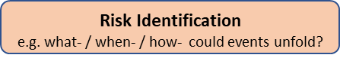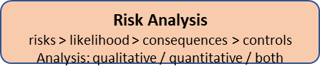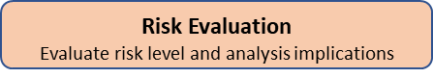
Likelihood: Common, Possible, Unlikely, Rare, Very Rare Consequence: Severe, Major, Moderate, Minor, Negligible Risk Level: Low, Medium, High, Extreme

