**Safeguarding Children and Vulnerable People**

**A CHILD AND VULNERABLE PEOPLE**

**PROTECTION POLICY**

**CODE OF CONDUCT**

**and Procedures**

September 2022 Version – approved by NSACC/SCU/SIC on _01/09/2022_

Signed:_____________________________

**Section 1. CHILD PROTECTION POLICY**

**1. INTRODUCTION**

**1.1 Policy Statement: A Commitment to Child Protection**

The purpose of this Policy is to guide <the church>in developing a child-protective culture. <The church> is committed to welcoming children and their parents or carers and providing a ‘child-safe’[1] environment, culture and programs for children and other vulnerable people who attend the services and other programs. Vulnerable people include children, young people, people with disabilities, anyone with mental health conditions and elderly people. We see such a commitment as flowing naturally from our vision and mission to operate according to biblical, Christian principles for living and for recognising the unique value and potential of every person, regardless of race, age, gender, ability or disability.

All children who come to <the church> have a right to feel and be safe. The welfare of children in our care will be our first priority. The authorised leaders accept the responsibility of providing a safe and friendly environment where children are listened to, feel safe, have fun, accept challenges, learn and grow. This duty of care applies at all times, although when children attend church and remain with their parents, then the parents have the primary duty of care.

We recognise the particular need for sensitivity for those from culturally and linguistically diverse backgrounds, and take into consideration the needs of children with disabilities and seek to include them and make them feel safe and welcome.

This Policy recognises both Federal and State legislation, as well as regulations and guidelines, and commits workers to responsibly and reasonably cooperating with Government departments, law enforcement and child protection agencies in any care proceedings. The operational principles of our Code of Conduct support and facilitate the protection of children and young people.

**1.2 Scope:**

The provisions and duties of care expressed in this Child Protection Policy apply to:

* Ministers. A minister of religion is: *A person defined or appointed as a recognised leader in an organised religious institution*; or *the appointed leader of a local religious congregation in an organised religious institution who has general authority*.
* The church council/session (including minister/pastor, elders & deacons)
* All employees (including volunteers) members and adherents/regular attenders.
* All activities and programs organised by or with the approval of <the church>, on the premises or off-site, including camps and day trips.
* *Where the church hires out its venue or facilities, the provisions of this policy applies to all guests or hirers of the venue and its facilities.* Such temporary users of the church facilities will be provided with copies of this Policy Code of Conduct and relevant procedures. The Hiring Agreement will include a signed commitment to complying with the expectations of these documents.

**1.3 Authority**

This Child and Vulnerable People Protection Policy and Code of Conduct was revised and updated to reflect the most recent changes to State and Federal law and guidelines towards being a child-safe organisation.

It was approved by the church council/session and adopted for use by <the church> on <date>.

**1.4 Policy Review**

The Child and Vulnerable People Protection Policy, Procedures and Code of Conduct will be reviewed at least every two years, or as required with the declaration of relevant legislation to remain compliant with the new legislation.

Any proposed changes or updates will be submitted to the Board of <the church> for approval at a properly convened meeting for approval before being adopted and implemented. Substantial changes or changes that alter the intent of this document must be approved by the Safe Church Unit.

**1.5 Operating Principles**

***Duty of Care:*** Means any legal responsibility that <the church> has to endeavour to ensure the safety and wellbeing of those who participate in programs or activities of the church and to provide an adequate level of protection against harm.

***Vicarious Liability:*** Means any legal liability that <the church> may be determined to have for the conduct of those who act on its behalf (e.g. its staff and approved voluntary leaders).

***Reasonable Standard of Care:*** Refers to the level of care that a user may reasonably expect that <the church> will take in providing any program, activity, service, or facility.

***Reasonable Foresight:*** Refers to a responsibility that <the church> has, when planning activities for children and young people, to identify any reasonably foreseen danger/risk and take reasonable steps to prevent or avert such risk by completing a risk assessment process prior to the activity commencing.

***Child Protection Reporting Obligations:*** This principle covers mandatory reporting, for those professions and persons that are defined by law, and the moral and legal responsibility that all adults have to report all types of known or possible child abuse, where there is a reasonable belief that a physical or sexual offence has occurred or may be committed against a child.

***Reasonable belief:*** A person may form a belief on reasonable grounds, through disclosure by the child or a third party or personal observation of indicators that a child is in need of protection after becoming aware that a child or young person is likely to be abused.

**2. Safety and Participation for Children and Vulnerable People**

The staff and leadership of <the church> encourage children to feel a part of the church by seeking their feedback regarding children’s programs, and through listening to them when they speak about matters that directly affect their sense of safety or wellbeing.

Part of our work with children is to *teach and inform* them of what they can do if they feel unsafe, threatened or upset by the behaviour of adults or other children. *We will listen to and act on* any concerns children or their parents/carers raise with us.

We value diversity and we undertake to treat everyone with respect both in our words and our practices.

*We are committed to protecting children from harm.* ‘Harm’, as used in this policy, includes any and all of the following types of abuse or neglect of children and young people: physical; sexual; emotional/psychological or any other form of abuse. (See Appendix 6)

We recognize that vulnerable people need protection from harm which includes the same forms of harm as those identified for children, and may also include Family and Domestic violence, Financial abuse, Indecent assault, Sexual harassment, Image Based abuse etc. (See Appendix 6).

**2.1 Feedback from Children**

Children and young adults will have the opportunity to reflect on their experience of church programs and to make comments regarding the standard of planning for and delivery of programs for their age-group. We will invite comments on other aspects of wellbeing, including staff conduct. Such feedback will inform <the church> and guide adjustments to practices, programs and training. (See Appendix 7)

**3. Employment of Staff and Volunteer Leaders**

**3.1 Recruitment, screening and selection practices**

<The church> will be vigilant in the recruitment, selection and screening of all staff, leaders and volunteers to ensure they are safe and suitable to work with children and young people. It is important that every person who works with children under the auspices of this church upholds and exemplifies our Christian beliefs and values, especially in their interaction with children and other vulnerable people.

1. To ensure proper oversight and understanding of the recruitment process, all members of the church council/session (ministers, elders and deacons- as specified by various state laws) will have a valid and current Child related Employment Screening Clearance (WWCC, WWVP, Blue Card, Ochre Card) and have had ChildSafe training.
2. The statements of commitment to child safety and the behavioural expectations of employees and volunteers are included in all advertisements and Job Descriptions.
3. A thorough screening will be conducted to determine whether a prospective staff member, volunteer or leader may pose a risk to children. This will include the church leadership making reasonable efforts to gather, verify and record the following information about a person whom it proposes to engage to perform child-connected work:
   1. The applicant will have been known to the leadership for a period of at least 12 months;
   2. Child-related Employment Screening Clearance;
   3. proof of personal identity and any professional or other qualifications;
   4. the person's history of work involving children;
   5. at least 2 references that address the person's suitability for the job and working with children; and
   6. Any National Register established by the CRCA.
4. The type of evidence that an applicant is required to provide to the <church> will vary depending on the type of position that they are applying for. However, <the church> will not offer any applicant a position of responsibility until they provide the required evidence to the [insert applicable person].
5. Short-listed applicants will be interviewed by church council members/activity leaders, prior to appointment being made. The church council/session will make appointments to a specific paid role in the form of an Employment Contract.
6. All workers who do not have a current written employment contract are to enter into a ministry/organisational covenant dealing with their suitability to be workers and agreeing to these child protection policies, procedures and the Code of Conduct. (refer appendix 10)
7. In line with legislation, parents of children who are involved with <the church> events/ministries can attend such with their child even though the parent(s) does not have a WWCC. Should such a parent become a leader/participant of such events/ministries they are required to obtain a WWCC. Otherwise, in general, people that do not have a valid and current Child related Employment Screening Clearance (WWCC, WWVP, Blue Card, Ochre Card) are not allowed to be engaged in any children’s programs.
8. In the case of contractors (tradespeople, IT personal etc) working on the church facilities, the church council/session, in ensuring the safety of children and vulnerable people, has the right to request a WWCC, though such is not legally required. The church council/session will in all circumstances ensure such contractors are appropriately supervised, especially if children are on the premises.

**3.2 Support and Training**

***We provide a system of induction, support and supervision*** *so people feel valued, respected and fairly treated. To this end we have developed a Code of Conduct to guide our staff and volunteers.*

1. Staff and volunteers are provided with a copy of this **Child Protection Policy**, **Code of Conduct and Procedures** that defines unacceptable conduct, boundaries and expectations for behaviour. Staff will sign a pledge stating they have read, understand and will comply with guidelines and follow procedures faithfully. (See Appendix 10)
2. <Annual> *‘Refresh, Renew, Update’* sessions are run for all program staff and volunteers, to ensure staff and volunteers’ awareness of the importance of child safety and familiarity with child protective practices and reporting expectations, and where there have been changes to legislation or practice.
3. Paid staff and the leadership team will attend workshop/training sessions organised by the denomination or other Registered Training Organisations at least every three years.
4. People that have not successfully completed their training program are not allowed to be engaged in any children’s or other ministry programs.
5. **Reporting and Investigation of Suspected Child Abuse**

Child abuse, especially sexual abuse of a child must be reported, where a reasonable belief is held that the child concerned has been abused, is being or is likely to be abused. A responsible adult can come to a reasonable belief through:

1. Disclosure by a child about abuse.
2. Disclosure by another child or an adult about abuse to a child, or
3. Direct observation of the abuse or evidence of it by the reporting adult.

The identity of the abuser and the circumstances of the event determine the procedure that should be followed by the leadership, employees or volunteers of <church>.

* 1. **Abuse of a Child Outside of the Church**

If a child attending a <church> program discloses abuse against them or to another child by a person **outside of the <church>** **community**, then the procedures outlined in **Reporting** **Procedure 1** (Appendix 1 and 1A)must be followed. All such disclosures should be written up on a **Complaints Reporting Form** (Appendix 2) and the Child Protection Officer/Pastor/Safe Church Coordinator informed.

However, it is the duty of the person to whom the disclosure was made to report the matter to either the Police or Child Protection Services following the Reporting Procedure 1. The church leadership may also decide to make a report.

In this case, ***no further investigation by the church is required***. It is important that no further information is obtained from the child by the church until the matter has been notified and further direction has been forthcoming from the appropriate authority. This is to ensure there is no contamination of evidence if the matter were to proceed to court. Neither is the child to be asked ‘leading questions’ as such may be deemed to contaminate evidence if legal proceedings are determined.

At all times, all reasonable steps to protect the child from harm should be taken.

**4.2 Abuse of a Child by a <church> employee, volunteer or member.**

In the case of an allegation being made against a staff member, volunteer, leader or contractor at <church>, the Child Protection Coordinator/Safe Church Coordinator will follow the Reporting Procedure in **Procedure 1** (Appendix 1 and 1B) to notify both the church leadership team and either the Police (if the matter is deemed severe or criminal) or the Child Protection Unit of the state authority.

In this case, then the additional requirements of the **Reportable Conduct Scheme**[2] (See Appendix 4) must also be followed by the <head of entity>, summarised here:

<Church> will take all steps to ensure that the safety of the child is paramount.

**Step 1.** Ensure that the details of the allegation are recorded on a church **Complaint and Abuse Form**, and the Pastor or Leadership Team is informed. Report the matter to the Police or the State Authority.

**Step 2.** Guidance needs to be sought from the Police or Child Protection Agency about suspending an alleged abuser, balancing the need to prevent evidence removal with the safety of the child. When so advised the accused person should be withdrawn from active duty, which could entail standing down (with pay, where applicable), re-assignment to other duties that do not have direct contact with children, or to work under increased supervision while the matter is being investigated.

**Step 3.** Notify the ***<state appointed agency to receive Reportable Conduct notifications>*** in accordance with the Reportable Conduct Scheme guidelines, within the timeframe specified (In Victoria 3 (working) days, NSW 7 days and ACT 30 days).

**Step 4.** The investigation process should be completed within 30 days of notification, and the report of the investigation, including findings and actions taken (or decision not to act) will be sent to the <Agency>. In some cases it may be appropriate to bring in an investigator from outside the church, to avoid conflicts of interest. If the case has been reported to authorities, investigations by <Church> should only be conducted when the authorities have approved this investigation.

**Step 5.** When a report is made, the leadership will contact the insurer via GJ Insurance Consulting Pty Ltd. Ph 1300 384 799 or insure@gjic.com.au

**4.3 Investigations**

<Church> will appropriately investigate all allegations relating to an incident of abuse in accordance with its obligations and to the extent reasonably practicable.

In some circumstances, as described by the **Reportable Conduct Scheme**, it may be necessary for <church> to conduct an investigation ***in addition to*** any investigation conducted by authorities (e.g. the police). <The church> may conduct an independent investigation into the allegation to the extent that it will not interfere with investigations by the state child protection authority or the police and will co-operate with the authorities as required. All people covered by this Child Protection Policy, Code of Conduct and Procedure must co-operate fully with any investigation by the Department, the police or <the church>.

In some circumstances, it may be appropriate for <the church> to engage a person (or persons) from outside <the church> to conduct an independent investigation in relation to allegations. [3]

<The church> will make every effort to keep any such investigation confidential; however, from time to time other employees, leaders, volunteers and contractors may need to be consulted in conjunction with the investigation (e.g. to provide witness statements).

**4.4 Case management**

In the event of a child or vulnerable person disclosing an incident of abuse to someone they trust it is essential that it is dealt with swiftly, sensitively and professionally.

An investigation conducted by <the church> will be conducted in accordance with procedural fairness to protect the integrity of the investigation and the interests of all the participants involved in the investigation. <The church> will also handle the allegations in a confidential manner to the greatest extent possible. The outcome will depend on the findings of the investigation, but may be (but not limited to):

* withdrawal from current role;
* re-assignment to duties with no contact with children;
* increased supervision;
* disciplinary action, dismissal or criminal prosecution;
* deposition from office.

**5 Risk Management**

<The church> will ensure that child safety is a part of its overall approach to risk management.

Risk assessment and management practices are embedded in our procedures for all services, programs or activities authorised by the church. We use these practices to inform our planning and implementing of all aspects of operation at <the church>.

Risk management applies to Work Health and Safety generally and is covered in more detail in <other policies>. This policy applies specifically to the minimising of risks of abuse of any kind to children and vulnerable people who are in our care and to ensuring their physical safety in the buildings or activities of the church. <The church> has zero tolerance of child abuse of any kind.

In situations where a person seeks to attend or join <the church>with a record of offending in child abuse of any kind, the leadership will put in place appropriate boundaries restricting access, to ensure the safety of children. This is not to say that such a person, with a proven reformed attitude, cannot be received into fellowship and benefit from the pastoral care of the church. Please refer to the Person of Concern process document using this [– link](https://safechurchcrca.org.au/safe-church-documents/2-policy-documents). ([https://safechurchcrca.org.au/safe-church-documents/2-policy-documents](https://apac01.safelinks.protection.outlook.com/?url=https%3A%2F%2Fsafechurchcrca.org.au%2Fsafe-church-documents%2F2-policy-documents&data=04%7C01%7C%7C321d7d64f98c41d6958408d915c04fb1%7C84df9e7fe9f640afb435aaaaaaaaaaaa%7C1%7C0%7C637564737993456653%7CUnknown%7CTWFpbGZsb3d8eyJWIjoiMC4wLjAwMDAiLCJQIjoiV2luMzIiLCJBTiI6Ik1haWwiLCJXVCI6Mn0%3D%7C1000&sdata=kdfglV%2FpHEggHx5%2F9NUfYzH9dIGZfemO0RFd9UUWM%2B8%3D&reserved=0))

<The church> will have <a risk and compliance sub-committee>[4] committed to identifying and managing risks within <the church> and its environment. If <this Committee> identifies risks of child abuse occurring in <the church> or its environment the committee will make a record of those risks and specify the action(s) the <the church>will take to reduce or remove the risks (i.e. risk controls).

As part of its risk management strategy and practices, the <Committee> will monitor and evaluate the effectiveness of the implementation of its risk controls.

All programs and activities must have a risk assessment completed before the program or activity is approved by the Safe Church Coordinator.

A **Child Protection Officer/Safe Church Coordinator** is appointed by the leadership for responding to complaints made by staff, contractors, volunteers, children or other attendees and members of the congregation.[5]

The Child Protection Officer (CPO)/Safe Church Coordinator will be identified, and their role explained at appropriate times in the church year. Guests, staff and volunteers are expected to use either the **Complaints Form** or the **Incident Form** to note concerns arising from observations or experience. (See Appendices 2 and 5) Copies of these forms will be kept in the Church Office by the CPO.

**6 Record Keeping**

All reports of alleged abuse or harm, or risk thereof, must be recorded in the form of a Complaint, Incident or Abuse Report. This will record places, times, dates, names of people, observable behaviours or evidence of harm. Reports must be to be securely stored by the CPO/Safe Church Coordinator. They provide valuable legal documents for any investigations and demonstrate the churches due diligence.

The denomination has established a National Register, with specific reference to implementing Recommendation 16.58* of the Royal Commission into Institutional Responses to Child Sexual Abuse. <The church> which employs and/or appoints individuals to roles within the Church will be required to contact the Safe Church Unit prior to employment/appointment, to gain clearance via the Register. The National Register records information that assists the Church to identify and respond to any risks posed to children by people in ministry.

The names of all persons who:

* apply for a Working with Children Check (or equivalent)
* are Ministers
* are paid employees or volunteer ministry workers of <the Church>

will require a clearance via a check of the Church National Register by the Safe Church Unit before they may be admitted to any new role or ministry.

The National Register will include information about persons who have been involved in the life of the Church, and are or have been:

* Charged with or convicted of an offence or offences against the person – including sexual offences;
* Had a Working with Children Check (or equivalent) clearance withdrawn, suspended, barred or revoked;
* The subject of a substantiated complaint of child sexual abuse;
* Listed on the Sex Offenders Register;
* Subject to a risk management plan or party to a relevant behavioural [or safety] agreement under the authority of a relevant Court of the Church.

Once established, the procedure for requesting and attaining clearances will be communicated to all churches and Safe Church Coordinators.

*The recommendations can be found at [www.childabuseroyalcommission.gov.au](http://www.childabuseroyalcommission.gov.au)

**7 Privacy and Confidentiality**

<The church> collects personally identifiable and sensitive information of all people who fulfil a role within the church. <The church> will collect, use, disclose, and store such information in accordance with the “Australian Privacy Principles” as described in the Privacy Act (1988).

As much as is reasonably possible, an individual’s confidentiality is to be protected. Both those who are making reports and those about whom accusations are being made are entitled to confidentiality. Where there is suspected abuse or misconduct, staff members, leaders, volunteers and contractors must not disclose or make use of the information in a manner that breaches confidentiality, other than to report and act in a way consistent with the Child Protection Policy, Code of Conduct and Procedure, and relevant statutory requirements.

**Section 2. CODE OF CONDUCT**

**1.1 Purpose:**

<The Church> is a group of followers of Jesus Christ in (suburb/locality) seeking to reflect the teachings of Christ and of the New Testament with integrity and humility. Beyond personal faith in the redeeming work of Christ in His death and resurrection, we accept that our faith is worked out and expressed in the quality of relationships we develop as a church community and all those with whom we interact in our daily lives. Jesus summarised God’s expectation for the conduct of His people into one famous and succinct sentence: *‘You shall love the Lord your God with all your heart, soul, mind and strength, and your neighbours as yourself.’* He reinforced this ‘law of love’ by adding, *‘By this shall all men know that you are my disciples; you love one another!*’ Jesus also taught and demonstrated the importance of truth and honesty, of justice and mercy as essential to healthy relationships.

This **Code of Conduct** seeks to apply to the ministerial, or pastoral relationship those ethical standards that God expects of all people. People in various forms of recognised ministry are therefore expected to be examples and models of Christian faith and practice. It is the duty of any person in a ministry position not to use the influence or authority of their position for personal gain, whether that gain is financial or in terms of power, sexual gratification, or otherwise. This includes any action, verbal, written or electronic, physical or emotional that could be interpreted as emotional, sexual or other abuse, and applies especially when working with children. We recognize the power differential between children and adults in ministry roles, and these guidelines seek to ensure that such a power is not used to harm children or any vulnerable person.

The adoption of this **Code of Conduct** and the related **Procedural Documents** for investigating breaches of the Code, reflects a deep desire for an open, accountable process that seeks to express justice, love and compassion to all parties, rather than to protect the organization.

**1.2 Our Commitment**

Our commitment to expressing the love of Christ leads us to the view that all people should be able to live, work and learn in an environment that is free from abuse of any kind. Our commitment is to cultivate an environment and culture where a diversity of people, regardless of age, gender, race and culture can thrive and grow holistically. That is, we are committed to <the church> being a safe place for all people, with a special focus on the safety and wellbeing of children and vulnerable people.

This **Code of Conduct** aims to detail the standards of conduct expected by staff (paid and voluntary) in the performance of their duties and to provide guidance in areas where there is a need to make personal and ethical decisions.

At the time of this revision, the **Code of Conduct** recognises and is aligned with all statutory and compliance requirements enshrined in State and Federal law. <The church> is committed to operating in accordance with the law in all its operations so that it provides a safe, ethical and caring place for all users and activities.

**2. Specific Expectations to Protect Children from Abuse**

All those who minister or work under the auspices of the church with children should be fully aware of the **Child and Vulnerable People Protection Policy** and **Code of Conduct.** Abusive behaviour towards children will not be tolerated and any and all allegations will be reported and investigated.

**2.1 DO:**

* contact the police if a child is at immediate risk of abuse (telephone ‘000’);
* adhere to the Child and Vulnerable People Protection Policy and Procedure and uphold the <the church>’s commitment to child safety at all times;
* take all reasonable steps to protect children from abuse, recognising your duty of care;
* maintain a duty of care towards others involved in these programs and activities;
* conduct themselves in a manner consistent with their position as an employee, volunteer, leader or contractor of <the church> and as a positive role model to children and young people;
* work towards the achievement of the aims and purposes of <the church>;
* be responsible for relevant administration of programs and activities in their area;
* establish and maintain a child-safe environment in the course of their work;
* be fair, considerate and honest with others;
* Treat all children and young people with respect, fairness, compassion and encouragement and value their input and opinions regardless of race, colour, sex, language, culture or other differences;
* promote the safety, participation and empowerment of all children and young people;
* listen and respond to the views and concerns of children, particularly if they are telling you that they are or another child has been abused or that they are worried about their safety/the safety of another child;
* ensure (as far as practicable) that adults are not alone with a child, or, at least, observable by another adult.
* raise concerns about suspected abuse with the Child Protection Officer or a leader as soon as possible;
* comply with all reporting obligations as they relate to reporting under legislation;
* record and act upon all allegations or suspicions of abuse, discrimination or harassment;
* if an allegation of child abuse is made, ensure, as quickly as possible, the immediate and ongoing safety of the child or children;
* be professional, consistent and responsible in all your actions;
* maintain strict impartiality;
* respect confidentiality when sharing information about children in accordance with the Child and Vulnerable People Protection Policy and Procedures and your reporting obligations.

**2.2 DO NOT:**

All people involved in the care of children on behalf of <the church> must not:

* ignore or disregard any suspected or disclosed child (or any other) abuse;
* put a child at risk of abuse (for example, by locking doors for an improper reason);
* speak to a child in a way that is or could be construed by any observer as harsh, threatening, intimidating, shaming, derogatory, demeaning, or humiliating. Some examples are:
  + swearing or using inappropriate language in the presence of a child;
  + yelling at a child, except in an emergency situation where the child’s safety may be in danger;
  + dealing with a child in anger; and
  + using hurtful sarcasm.
* discuss sexual activities with a child, unless it is a specific job requirement and the person is trained or qualified to discuss these matters (and it is part of an approved program or activity);
* have private contact with a child outside of church activities without the knowledge and/or consent of <the church>’s leadership or the child’s parent or guardian;
* have any online contact with a child (including by social media, email, instant messaging etc.) or their family (unless necessary and approved by the church and the child’s parents/guardians, using an approved church email or social media account);
* use any personal communication channels/devices such as a personal email account or social media to communicate with a child without parental knowledge; Refer in this regard to Appendix 11
* exchange personal contact details such as phone number, social networking sites or email addresses with a child (unless necessary and approved by the church and the child’s parents/guardians as the agreed form of communication);
* use, possess, or be under the influence of alcohol while in the presence of or while supervising a child (unless your contact with the child is accidental/incidental and you are not performing your duties as directed by <the church>);
* use, possess, or be under the influence of illegal drugs while in the presence of or while supervising a child;
* provide or allow a child to consume alcohol;
* provide or allow a child to consume illegal drugs;
* initiate unnecessary physical contact with a child or young person, or do things of a personal nature for them that they can do for themselves;
* engage in rough physical games, hold, massage, kiss, cuddle or touch a child in an inappropriate and/or culturally insensitive way;
* engage in any sexual contact with a child for any purpose;
* take a child to your home or encourage meetings outside program activities (unless necessary and approved by the church and the child’s parents/guardians);
* be naked in the presence of a child;
* possess sexually explicit printed materials (magazines, cards, videos, films, clothing, etc.) in the presence of children;
* sleep in the same bed, sleeping bag, room or tent with a single child;
* treat any child or young person disrespectfully, unfairly, harshly or discouragingly based on their age, gender, race, culture, disability or any other differences;
* engage in any activity with a child that is likely to emotionally harm them (e.g. watch a movie that is age or content inappropriate for a child);
* be alone with a child unnecessarily and for more than a very short time, unless you are observable by another adult or it is unavoidable;
* develop a ‘special’ relationship with a specific child for your own needs;
* show favouritism through the provision of gifts or inappropriate attention;
* photograph or video a child without the consent of the child and his/her parents or guardians;
* do anything in contravention of <the Church>’s policies, procedures or this Code.

**DECLARATION**

I, _________________________, have read the Code of Conduct and the Child and Vulnerable People Protection Policy and Procedures that express the intent of the church to protect and nurture children and other vulnerable people.

I agree to comply with these rules and expectations. I understand that if I breach the Code of Conduct or commit an act of serious misconduct or break the law, this may lead to my:

* suspension from duties during investigation of allegations against me;
* termination of employment without notice or payment in lieu (summary or instant dismissal);
* being reported to the police and charged with a criminal offence.

Signed: _____________________________________ Date: ____ / ____ / 20___

Signed: _____________________________________ Date: ____ / ____ / 20___ <Employer or Senior officer of the Church>

**Section 3. CHILD PROTECTION PROCEDURES & FORMS**

**3.1 Complaints and Allegations**

Any person who believes a child is at immediate risk of abuse should telephone 000.

Certain professions are referred to as ‘mandatory reporters’. This includes medical practitioners, nurses (including school nurses), members of the police force, religious leaders (pastors, including elders and deacons), counsellors and primary and secondary teachers and principals. Penalties may be incurred by those named as ‘mandatory reporters’ if they fail to notify the Child Protection agency if they have reasonable grounds for a belief (not proof!) that a child or young person is in need of protection, because they have suffered, or are likely to suffer significant harm, particularly physical or sexual abuse.

In addition to the mandatory reporting obligations above, **any person** who believes on reasonable grounds that a child is in need of protection from child abuse, should disclose that information to the Police or the Child Protection. In Victoria, Queensland and New South Wales ‘Failure to Report’ is a crime!

**3.2 When is a child or vulnerable person in need of protection?**

A child or vulnerable person is in need of protection if any of the following grounds exist—

1. the child has been abandoned by his or her parents;
2. the child's parents are dead or incapacitated and there is no other suitable person willing and able to care for the child;
3. the child has suffered, or is likely to suffer, significant harm as a result of physical injury and the child's parents have not protected, or are unlikely to protect, the child from harm of that type;
4. the child has suffered, or is likely to suffer, significant harm as a result of sexual abuse and the child's parents have not protected, or are unlikely to protect, the child from harm of that type;
5. the child has suffered, or is likely to suffer, emotional or psychological harm of such a kind that the child's emotional or intellectual development is, or is likely to be, significantly damaged and the child's parents have not protected, or are unlikely to protect, the child from harm of that type;
6. the child's physical development or health has been, or is likely to be, significantly harmed and the child's parents have not provided, arranged or allowed the provision of, or are unlikely to provide, arrange or allow the provision of, basic care or effective medical, surgical or other remedial care;
7. the child or vulnerable person has suffered, or is likely to suffer, bullying, image based abuse or similar harm of such a kind that the vulnerable person’s emotional or intellectual development is, or is likely to be, significantly damaged;
8. the vulnerable person has suffered, or is likely to suffer financial abuse or similar harm of such a kind that the vulnerable person’s financial position is, or is likely to be, significantly damaged;
9. the child or vulnerable person has suffered, or is likely to suffer spiritual abuse or similar harm of such a kind that the vulnerable person’s emotional or intellectual development is, or is likely to be, significantly damaged.
   1. **Making and Managing an Allegation of Abuse**

**1**. Where possible, any person (including a child or parent) making an allegation of child abuse should be encouraged to fill out a **Complaints Form** (Appendix 2) and give this to the CPO/Safe Church Coordinator. If they are not willing or able to fill out the Form, the CPO (or other leader) may take notes and fill out the form at a later time. The CPO **will** share the allegation with the senior leader of <the church>. A copy of this Form **must** be kept by the CPO. The complainant may keep the original. This is an essential record of the event.

If a child is concerned about their own safety or the safety of another person, the child may speak to the **Child Protection Officer (CPO)/Safe Church Coordinator**. The CPO will meet with the complainant, and hear the story, taking notes and seeking clarification, ensuring that the complainant feels listened to, understood and protected.

The gathering of minimal information to make a reasonable decision is required. Any conversation with a child or young person needs to be recorded word for word if called upon for evidence. No question is to be ‘leading’ or introducing material the child or young person has not self-disclosed.

**2.** Any responsible adult should, if they have come to a reasonable belief that abuse of a child has happened, is or is likely to happen, follow the steps outlined in **Reporting Procedure 1** (Appendix 1A) below. This includes senior leadership, or any concerned member of the church.

**3.** If the allegation is made against an employee, volunteer or worker in a church program or activity, then the <head of entity> must ALSO follow the steps outline in **Reporting Procedure 2:** (Appendix 1B)

**Appendix 1. Reporting Procedure 1**

**1. Clarifying, Recording Evidence and Specific Information about the Child**

*A Report is required if you believe, based on reasonable grounds, that a child has suffered, or is at risk of suffering, significant harm as a result of physical, sexual, emotional abuse or neglect AND that the child’s parents or caregivers have not, or are unlikely to, protect the child from such harm.*

The following information will be required when making a formal report to either the Police or Child Protection Services.

* The child’s name, age (date of birth is preferable) and address
* The name, age and address of any known siblings
* Your reasons (observations or disclosures) for believing that the child is at risk of abuse, or actually being abused or neglected
* Your assessment of the immediate danger to the child
* Current whereabouts of the child or vulnerable person (if not in the home)
* Your description of injuries or ‘sign’ behaviours you have observed
* Any other information you may have of relevance to the investigation
* Information link for all States/Territories – click [here](https://aifs.gov.au/cfca/publications/mandatory-reporting-child-abuse-and-neglect) (https://aifs.gov.au/cfca/publications/mandatory-reporting-child-abuse-and-neglect)

**2. Fill out a Complaints Report Form (Appendix 2)**

*N.B. You do not have to be given permission by church authorities to make such a report. Your identity as notifier will remain confidential unless you choose to inform the child or family.*

**3. Reporting.** Making a report is to lay a serious allegation of a criminal offence against another person, so clarify your perceptions carefully before reporting.

You can make your report to:

* **<The church> Child Protection Officer/Safe Church Coordinator**, using a Complaint Form. Attach your notes to the form, keeping a copy. Please note, the CPO will inform the senior leadership of the church of your report, and they will act in accordance to law. You may still make an independent report to:
* **The Police.** (Ring 13 14 44) The police are the most appropriate first responders if the report is regarding abuse that is immediate, criminal or endangering the child on church premises in another location. If the child is in immediate danger call 000.
* **Child Protection Services**

Victoria: (1300 655 795 BH, or 13 12 78 AH) is a statutory service provided by DHHS to protect children and young people at risk of harm and to work with families to ensure these risks are mitigated.

* **All State Child Protection Services – click** [**here**](https://aifs.gov.au/cfca/publications/cfca-resource-sheet/reporting-child-abuse-and-neglect)**.**  (https://aifs.gov.au/cfca/publications/cfca-resource-sheet/reporting-child-abuse-and-neglect)

**Appendix 1A Reporting Procedure 1**

**Appendix 1 B Reporting Procedure 2**

**Reporting Child Abuse – In your Church/Workplace**

The chart below outlines the process that a person working with children in a specific setting should follow to protect a vulnerable child from actual or possible abuse, from someone who is an employee, volunteer or adherent of the church or organization. Even if you know the person as a colleague your first duty is to safeguard the child.

|  |  |
| --- | --- |
| Disclosure | By a child who is being abused  By another child or adult  By personal observation |
| “Reasonable Belief” | Through observation, listening, checking with other adults you came to a **reasonable belief** that a child has been abused, is being abused or in danger of being abused (see definitions appendix 6). |
| Recording/Documenting | Make notes of observations and information gathered. Record data such as: the name, age, gender, current location or address of the child, describe any visible injuries or relevant behaviours. Note the identity of the abuser (if known), **DO NOT** confront this person unless to protect a child from immediate danger.  **Do not** interrogate the child or ask leading questions.  Fill out a Complaint Reporting Form if possible, even if you wish to make a verbal complaint also. If you have access to SMO (Safety Management Online) please enter the complaint as an incident as soon as possible. |
| Severity | **Criminal** – sexual or **Misconduct** – sexual, physical,  physical abuse, grooming emotional or severe neglect |
| Report to: | **The police State Authorities**  Ring 000 if the child is in danger Child Protection Services  Ring 13 14 44 if not  Lodge your Complaint Reporting Form with the ChildSafe Coordinator (Safe Church Representative) or the chairman of session. |

There is nothing else you need to do as a responsible adult. Your identity as notifier will remain confidential unless you choose to inform the child or family.

Reporting Obligations of the “Head of Entity” (Chairman of Session) under a **Reportable Conduct Scheme**:

|  |  |
| --- | --- |
| **Notify** | Chairman has 3 working days (Vic – 7 days in NSW and 30 days in ACT) to notify the Agency Responsible for a reportable conduct allegation. |
| **Investigate** | You **must investigate** an allegation (subject to Police clearance on criminal matters), advise the Agency as to who is conducting the investigation, manage the immediate risks to children (e.g. remove the alleged offender from any contact with children – again after seeking advice from police). |
| **Update** | Withing 30 days, provide a report which updates the Agency with information and actions you have taken – even if your investigation cannot proceed on any advice from police. |
| **Outcomes** | Notify the Agency of findings and actions (or why non action was taken). |

**Refer appendix 4A, 4B or 4C for more details.**

**APPENDIX 2. Complaint and Abuse Reporting Form**

Please use the Form to report a Formal Complaint or Abuse of any kind towards yourself or another person, including a child. **Please read the Code of Conduct Document before using this form.**

**When should this report be completed?**

This report must be completed if:

1. There is an alleged illegal act, a participant sent home, serious leader dispute, damage or loss of property.
2. The situation relates to Child Protection (disclosure of abuse, allegation of abuse, or report based on reasonable grounds).
3. You have a grievance about anything relating to the activities or buildings/physical environment of the church.
4. Other situations will require judgement and consultation with your organisation. In situations where doubt exists about the use of this report, complete a report.

**What do I do with this report after I have completed it?**

1. Check that all information is correct to the best of your knowledge.
2. Check that the appropriate signatures are given.
3. The Team Leader forwards the form to your Coordinator as soon as possible. More severe complaints require immediate reporting, while other reports should be submitted within seven days.

The **Complaint and Abuse Report Form** can be downloaded using this link: [Link to Forms](https://safechurchcrca.org.au/safe-church-documents/4-forms).

(https://safechurchcrca.org.au/safe-church-documents/4-forms)

**APPENDIX 3. Managing Complaints and Investigations**

**Appendix 4A. THE REPORTABLE CONDUCT SCHEME (Victoria)**

THE REPORTABLE CONDUCT SCHEME outlines a series of responsibilities for the ‘head of entity’ (Chairperson) to undertake, where an allegation has been made about child abuse against a person who is acting for the church or participating in activities run by the church.

The following information is provided by the **Commission for Children and Young People.**

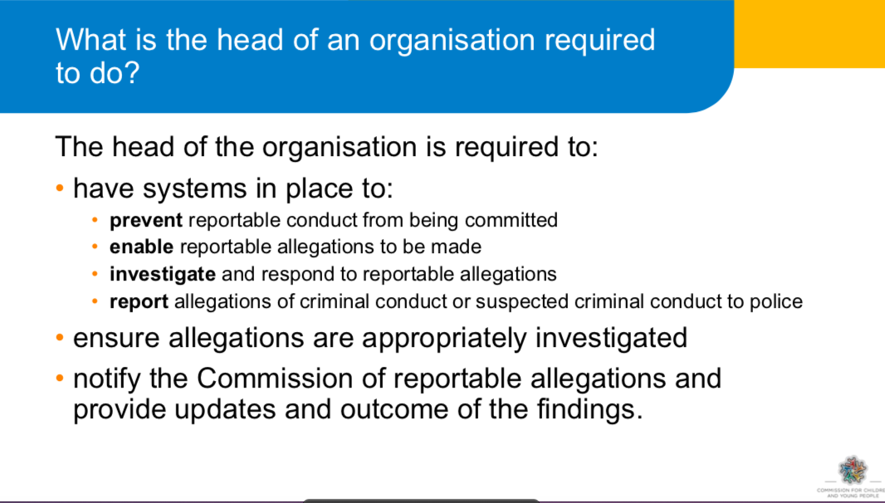

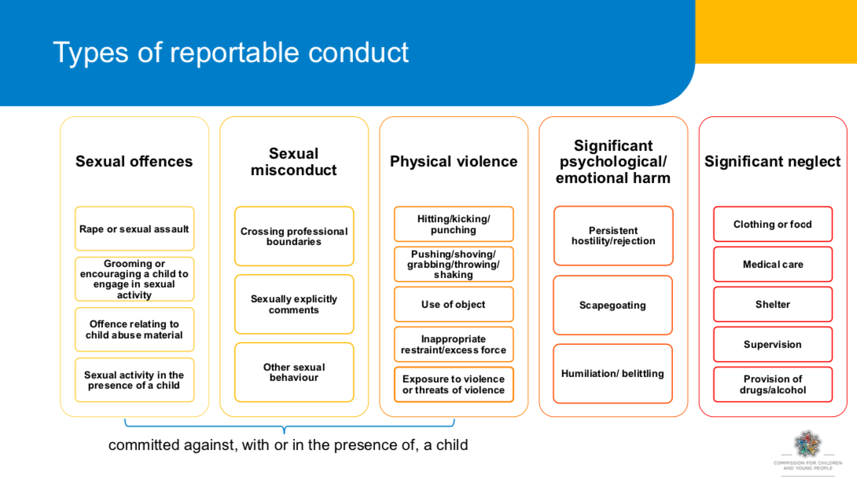

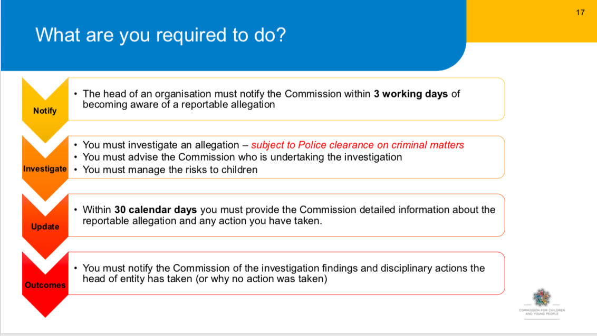

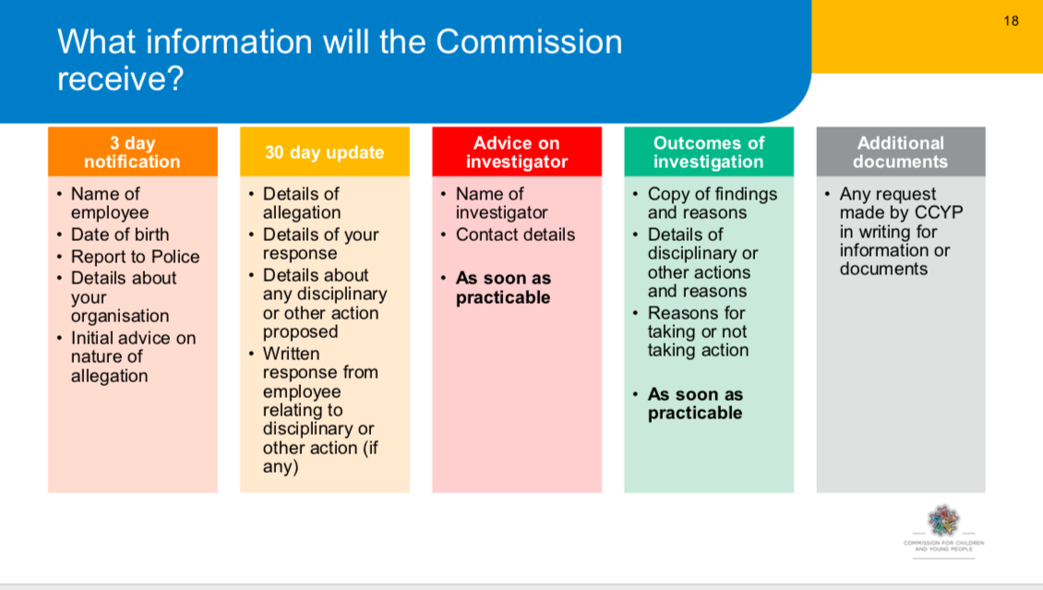

A more complete outline of the elements of the Reportable Conduct Scheme can be found at:

<https://ccyp.vic.gov.au/child-safety/resources/reportable-conduct-scheme-information-sheets/>

**Appendix 4B. THE REPORTABLE CONDUCT SCHEME (New South Wales)**

From 1 March 2020, the Reportable Conduct Scheme is operated by the Office of the Children’s Guardian under the Children's Guardian Act 2019.

The scheme monitors how certain organisations (‘relevant entities’) investigate and report on types of conduct ('reportable allegations' or 'reportable convictions') made against their employees, volunteers or certain contractors who provide services to children. The scheme will also cover religious bodies, in response to recommendations of the Royal Commission into Institutional Responses to Child Sexual Abuse.

From 1 March 2020, when the head of a 'relevant entity' becomes aware of a reportable allegation or a reportable conviction, the head of that entity must notify the Office of the Children's Guardian within seven business days and conduct an investigation into the allegations. If the final entity report is not ready to submit within 30 calendar days, the head must provide an interim report with information about the progress of the investigation and an expected timeframe for completion.

These entities are required to notify and investigate certain allegations (reportable allegations) of abuse involving a child when the allegation is against someone they employ, engage or contract in circumstances outlines by the legislation.

While a police investigation may have priority in these matters, the head of an entity still has to notify the Office of the Children’s Guardian within 7 business days of becoming aware of any reportable allegation or conviction and provide a final entity report or interim/update report within 30 calendar days.

Following notification of a reportable allegation, the Office of the Children’s Guardian can provide guidance to your entity about how to respond to the allegation.

The Reportable Conduct Directorate at the Office of the Children’s Guardian can also:

* monitor and guide the progress of the entity’s investigation into the reportable allegation or conviction
* require further information about the allegation or the entity's response to it
* assess whether the entity conducted a fair, transparent, effective and timely investigation
* determine whether appropriate actions have been taken by the entity following the investigation
* work with relevant entities to help them improve their systems for preventing reportable conduct and responding to reportable allegations.

Certain information may be shared within the Office of the Children’s Guardian and with external agencies to keep children safe. Click [here](https://www.kidsguardian.nsw.gov.au/child-safe-organisations/reportable-conduct-scheme/fact-sheets) for more information.  
(<https://www.kidsguardian.nsw.gov.au/child-safe-organisations/reportable-conduct-scheme/fact-sheets>)

**Appendix 4C. THE REPORTABLE CONDUCT SCHEME (Australian Capital Territory)**

**What does an organisation need to do?**

Organisations must have policies and procedures to prevent reportable conduct. They need to have processes to respond to allegations involving their employees.

This includes:

* educating employees about the scheme
* notifying the Ombudsman within 30 days of becoming aware of an allegation
* investigating allegations of reportable conduct and providing a report to the Ombudsman
* reporting to appropriate organisations such as ACT Policing.
* Use this checklist to ensure your organisation meets its requirements.

For more information see the Reportable Conduct Resource Kit. It includes information on how to develop a code of conduct: ACT Ombudsman practice guide No. 10 - [Addressing child protection issues in a code of conduct.](https://www.ombudsman.act.gov.au/__data/assets/pdf_file/0016/81007/No.-10-Addressing-child-protection-issues-in-a-code-of-conduct.pdf) (https://www.ombudsman.act.gov.au/__data/assets/pdf_file/0016/81007/No.-10-Addressing-child-protection-issues-in-a-code-of-conduct.pdf)

**How does an organisation notify the Ombudsman?**

Organisations must report allegations or convictions that occurred after 1 July 2017 to the Ombudsman. An organisation should:

* notify the Ombudsman within 30 days of becoming aware of the allegation by completing the section 17G notification form
* provide details of the allegation or conviction
* provide the organisation’s intended response, including an investigation plan and risk assessment
* report to appropriate organisations. These may include ACT Policing, Child Youth Protection Services and Access Canberra (Working with Vulnerable People).
* For more information, see the ACT Ombudsman Practice Guide No. 5: [Employer responsibilities.](https://www.ombudsman.act.gov.au/__data/assets/pdf_file/0012/81003/No.-5-Employer-responsibilities.pdf) (https://www.ombudsman.act.gov.au/__data/assets/pdf_file/0012/81003/No.-5-Employer-responsibilities.pdf)

If you have questions call us on 6276 3773 or email act@ombudsman.gov.au.

**What happens after notifying the Ombudsman**

Organisations should continue their investigation after notifying the Ombudsman about an allegation.

The Ombudsman can ask for progress updates of the investigation and relevant documents or information. In some cases the Ombudsman may attend interviews conducted by, or on behalf of, the organisation. We may share this information with ACT Policing and other key organisations.

**Organisation sends the investigation report to the Ombudsman**

After completing the investigation, the organisation emails the investigation report to the Ombudsman including the section 17J investigation report cover sheet. For more information see:

* Practice Guide No. 6: [Making a finding of reportable conduct](https://www.ombudsman.act.gov.au/__data/assets/pdf_file/0013/81004/No.-6-Making-a-finding-of-reportable-conduct.pdf) (https://www.ombudsman.act.gov.au/__data/assets/pdf_file/0013/81004/No.-6-Making-a-finding-of-reportable-conduct.pdf)
* Practice Guide No. 7: [17J final investigation report](https://www.ombudsman.act.gov.au/__data/assets/pdf_file/0014/81005/No.-7-17J-final-report.pdf) (<https://www.ombudsman.act.gov.au/__data/assets/pdf_file/0014/81005/No.-7-17J-final-report.pdf>)

**Ombudsman assesses the investigation report**

The Ombudsman then assesses the investigation report and may ask for further information. See: Practice Guide No. 9: [How the ACT Ombudsman assesses an organisation’s response investigation](https://www.ombudsman.act.gov.au/__data/assets/pdf_file/0015/81006/No.-9-How-the-ACT-Ombudsman-assesses-an-employers-response_investigation.pdf) ([No.-9-How-the-ACT-Ombudsman-assesses-an-employers-response_investigation.pdf](https://www.ombudsman.act.gov.au/__data/assets/pdf_file/0015/81006/No.-9-How-the-ACT-Ombudsman-assesses-an-employers-response_investigation.pdf) )

**Closure**

The Ombudsman provides feedback to the organisation and closes the case. For more information see: The ACT Ombudsman Practice Guide No. 1: [How the ACT Ombudsman Responds to Notifications and Reports.](https://www.ombudsman.act.gov.au/__data/assets/pdf_file/0035/80999/No.-1-How-the-ACT-Ombudsman-responds-to-notifications-and-reports.pdf) (https://www.ombudsman.act.gov.au/__data/assets/pdf_file/0035/80999/No.-1-How-the-ACT-Ombudsman-responds-to-notifications-and-reports.pdf)

Also see the [Reportable conduct flow chart](https://www.ombudsman.act.gov.au/__data/assets/pdf_file/0013/106501/ACT-Ombudsman-reportable-conduct-process-flowchart.pdf). (<https://www.ombudsman.act.gov.au/__data/assets/pdf_file/0013/106501/ACT-Ombudsman-reportable-conduct-process-flowchart.pdf>)

**How does the ACT Ombudsman support organisations?**

The Ombudsman supports organisations to prevent and report on child abuse and misconduct. It also monitors organisations’ responses. The Ombudsman:

* provides guidance on best practice, including how to conduct fair investigations
* monitors organisations’ investigations
* monitors organisation policies and procedures for preventing and responding to child abuse
* shares information with police and key organisations to better protect children from abuse
* receives complaints about the handling of allegations and convictions
* investigates allegations or an organisation’s response to an allegation.

**Other reportable conduct obligations**

*Do religious organisations need to report information heard during confession?*

Yes. From the 1 September 2019, religious organisations are required to report to the Ombudsman information heard during confession. Religious organisations must report allegations of reportable conduct made during a religious confession if they relate to child sexual abuse or non-accidental physical injury to a child.

Religious organisations must also nominate a head of entity and tell the ACT Ombudsman.

*Should an organisation notify the Ombudsman if ACT policing is already investigating?*

Yes. Organisations should notify the Ombudsman as soon as possible, especially when the police are involved. Organisations must tell the Ombudsman within 30 days of becoming aware of an allegation.

Organisations should wait for instruction from ACT Policing before starting their investigation. This includes telling the employee who is the subject of the allegation about the allegation.

*Should I report allegations that relate to events prior to 1 July 2017?*

If you received allegations after 1 July 2017 you will need to report them. It does not matter if the events occurred prior to this date.

*What is the difference between reportable conduct and mandatory reporting?*

Reportable conduct covers a wider range of behaviours other than mandatory reporting. This means organisations may need to report to the Ombudsman, but not Child Youth Protection Services. The Ombudsman oversees the organisation’s response to an allegation about its employee. Child Youth Protection Services will consider whether a child is at risk of harm and may take its own action.

If an allegation does not involve an employee or volunteer it is not necessary to report to the Ombudsman. Organisations may still need to report to the Child Youth Protection Service.

For more information see ACT Ombudsman Practice Guide No2: [Identifying Reportable Conduct.](https://www.ombudsman.act.gov.au/__data/assets/pdf_file/0009/81000/No.-2-Identifying-Reportable-Conduct.pdf) (https://www.ombudsman.act.gov.au/__data/assets/pdf_file/0009/81000/No.-2-Identifying-Reportable-Conduct.pdf)

**APPENDIX 5 INCIDENT REPORTING FORM**

Please use the Form to report an Incident. **Please read the Code of Conduct Document before using this form.**

**When should this report be completed?**

This report must be completed if:

1. An outside emergency service is contacted (Police, Ambulance, State Emergency Service etc.).
2. An individual is taken to hospital, doctor’s surgery, emergency dental surgery, or other medical professional.
3. An injury results in a participant being unable to participate for 24 hours.
4. There is an alleged illegal act, a participant sent home, serious leader dispute, damage or loss of property.
5. Other situations will require judgement and consultation with your organisation. In situations where doubt exists about the use of this report, complete a report.

**How do I complete this report:**

* Sections A, B & D must be completed in all situations.
* Section C is to be completed where there is an injury to an individual.

**What do I do with this report after I have completed it?**

1. Check that all information is correct to the best of your knowledge.
2. Check that the appropriate signatures are given.
3. The Team Leader forwards the form to your Coordinator as soon as possible. More severe incidents require immediate reporting, while other reports should be submitted within seven days.

The **Incident Form** can be downloaded using this link: [Link to Forms](https://safechurchcrca.org.au/safe-church-documents/4-forms) (https://safechurchcrca.org.au/safe-church-documents/4-forms)

**APPENDIX 6 Definitions of Abuse against Children**

**Child abuse includes:**

1. Any act committed against a child involving
   * 1. a sexual offence; or
     2. an offence under section 498(2) of the Crimes Act 1958 (grooming); and
2. the infliction, on a child, of-
3. physical violence; or
4. serious emotional or psychological harm; and
5. serious neglect of a child.

“Child” means a person under the age of 18 years unless otherwise stated under the law applicable to the child. Collective term for “child” is “children”.

The most prevalent types of abuse are physical, sexual, emotional, neglect and bullying.

1. **Physical Abuse**

Physical abuse is any non-accidental physical injury resulting from practices such as:

* Hitting, punching, kicking, beating (marks from belt buckles, fingers).
* Shaking (particularly babies).
* Burning (irons, cigarettes), biting, pulling out hair.
* Alcohol or other drug administration.
* Fractured bones – especially in young children.
* Strangulation.
* Unexplained or hidden injuries.

1. **Sexual Abuse, including ‘grooming’**

**Sexual abuse** is any sexual act or threat to perform such upon another person. It occurs when a person uses their power and authority to take advantage of another’s trust to involve them in sexual activity. It does not necessarily involve genital contact but is any act which erodes the sexual boundary between two persons. It may appear consensual but the validity of consent is negated by the power differential.

**Sexual grooming** is a pattern of behaviour aimed at engaging a child, as a precursor to sexual abuse. Examples include inappropriate special time with the child, inappropriately giving gifts, ‘accidental touching’, allowing the child to sit on lap, having secrets. In isolation, such behaviours may not indicate the risk of abuse occurring, but if there is a pattern of behaviour occurring, it may indicate grooming. Grooming behaviours often mimic the kind of relationship-developing strategies that Christian ministries use for the benefit and wellbeing of children, that is, gaining the trust of the child, demonstrating care and concern, spending time, visiting in the home, finding out about family, friends and hobbies. However, grooming to involve a child in sexual activities for the personal gratification of an adult is a crime.

The grooming process often starts with the person ‘grooming’ the organization or church by building trust. Then progressively the perpetrator starts to target families before starting to groom the child.

1. **Emotional or Psychological Abuse**

Emotional abuse is the chronic attitude or behaviour of one person, which is directed at another person, or, the creation of an emotional environment which erodes a child’s development, self-esteem and social confidence over time. Behaviours may include: devaluing, ignoring, rejecting, corrupting, isolating, terrorising or chronic and extreme domestic violence in the child’s presence.

1. **Neglect**

Neglect is characterised by the failure to provide for the child’s basic needs. It includes any serious omission or commission which jeopardises or impairs a person’s development. Examples include the failure to provide food, shelter, healthcare, adequate hygiene or schooling for a child.

1. **Bullying and cyber-bullying**

Bullying can be defined as repeated, unreasonable, unwanted behaviour conducted by an individual or group against another person, which has a negative impact on health and wellbeing. This includes aggression, verbal, emotional/psychological or physical acts or the use of social media or other forms of communication that intimidates, humiliates or threatens. It often involves an abuse of a power differential between the bully and the victim.

Cyber-bullying occurs when a person uses any form of telecommunication to sexually groom, bully, suggest an inappropriate relationship be formed, or engage a child in sexual language or behaviours. The explosion of electronic communications (Facebook and other social media sites, text-messaging, internet chat rooms etc.) has seen a sharp increase in cyber-bullying. Appendix 11 contains <church>’s electronic communication policy.

1. **Other abuse**

We recognise that abuse can also take many other forms, and we commit to treating all children and young people with respect, fairness, compassion and encouragement, regardless of any differences.

**APPENDIX 7 (Example) Feedback Survey of Children. Name:_________________**

This survey is your chance to have a say about the children’s programs. Think about each statement and mark on the line, somewhere between “Not at all!’ and ‘Absolutely!’.

1. **I feel welcomed and looked after when I come to this church..**

I__________________________________I_____________________________________I

Not at all. Mostly Absolutely!

1. **My parents like and follow the log-in process and arrangements for my care.**

I__________________________________I_____________________________________I

Not at all. Mostly Absolutely!

1. **I know which toilets to use and feel safe when using them.**

I__________________________________I_____________________________________I

Not at all. Mostly Absolutely!

1. **There are good spaces for activities and learning times.**

I__________________________________I_____________________________________I

Not at all. Mostly Absolutely!

1. **The activities are fun, challenging and well-organised.**

I__________________________________I_____________________________________I

Not at all. Mostly Absolutely!

1. **I feel safe and relaxed while I am in the children’s programs.**

I__________________________________I_____________________________________I

Not at all. Mostly Absolutely!

1. **I feel that the leaders know what they are doing and are looking after me.**

I__________________________________I_____________________________________I

Not at all. Mostly Absolutely!

1. **The leaders are friendly and respectful of my friends and me.**

I__________________________________I_____________________________________I

Not at all. Mostly Absolutely!

1. **If I am worried or upset, I know who I can go to for help.**

I_______________________________I___________________________________I

Not at all. Mostly Absolutely!

1. **I would recommend this church program as great for kids.**

I________________________________I___________________________________I

Not at all. Mostly Absolutely!

Appendix 8

MEDICAL & HEALTH INFORMATION – SPECIAL EVENT (EXAMPLE)

…………………………….…………………**(**Insert organisation name)**

Child’s Name:

(Surname) (Christian name) Date of Birth

Is your child taking any regular or currently prescribed medication? YES / NO

If so, please name the medication and provide details of dosage and administration.

Your child’s leader will administer medication to your child as directed by written instructions from you. Please clearly mark your child’s name on all medication along with the dosage and administration procedures.

Is there anything about your child’s health which means that s/he should engage in only limited physical activity? YES / NO

If so, please give details

Does your child require a special diet because of health problems? YES / NO

If so, please give details

Is there any other information which may help us care for your child? YES / NO

If so, please give details

Emergency contact 1. Name: ___________________________________ Mobile: _______________________

Emergency contact 2. Name: __________________________________ Mobile: _______________________

Preferred Medical Centre/ Doctor: ______________________________________ Phone: ________________

Do you have private medical insurance? Provider: ________________________________________________

**AUTHORISATION**

‘In the event of an accident or sudden illness, I authorise the person in charge to call an ambulance or to seek medical attention at my expense, should I not be contactable.’

Signed: ______________________________________________ Date: ___/____/20___

Parent/guardian/caregiver [Print name if not one of the above] _______________________________

Witness Name: _______________________________ Signature: _____________________________________

Appendix 9 Example Permission Form

PERMISSION TO ATTEND EVENT/CAMP FORM (EXAMPLE)

…………………………….…………………**(**Insert organisation name)**

As a parent/caregiver of:

I, give my consent for him/her to take

part in the <special activity or camp> to be held at the (event site)

from to (or on )

*(date) (date) (date)*

I have seen the attached copy of the programme for the (event)

and acknowledge that risk of injuries is inherent in physical activities. While I am aware that staff will take all due care, I recognize that accidents may occur.

The staff and supervisors have my authority to take whatever action they think necessary to ensure the safety, wellbeing and successful conduct of the participants as a group or individually in the above-mentioned activity.

If my child becomes ill or is accidentally injured, I authorise the person-in-charge to obtain on my behalf whatever medical treatment my child requires. I will agree to pay all such medical expenses.

I have attached information as asked concerning my child’s health including any relevant details of his/her limitations for the planned activity. My child’s own local doctor or medical specialist may be contacted in an emergency.

I also acknowledge that the <Church> and all its representative leaders or other helpers at <name of event> can accept no liability for any personal injury or property loss suffered by my child during the period of the <name of event>.

Signed: __________________________________________________ Date:___/____/20___ Parent/Guardian/Care-giver

Appendix 10 MINISTRY/ORGANISATIONAL COVENANT

**Of <Church>**

I, ______________________________________________

(Print name)

1. Declare that, except as is stated below,

(1) have not been guilty of any sexual misconduct against any person;

(2) have never committed any criminal offence involving fraud, violence or drugs;

(3) am of good character and suitable for ministry within **<Church>**.

(If exceptions to the above give details and if insufficient room place them in an attachment).

2. Acknowledge I have read and agreed to the <church’s> Child Protection Policies, Code of Conduct and the Child Protection Manual of Procedures.

1. Agree I will cooperate with the **<Church>** in any investigation undertaken in relation to a complaint or allegation of impropriety or misconduct made against me.
2. Agree I will attend and take part in education courses to prepare and equip me for ministry with children.
3. Acknowledge that by signing this covenant no legal contract is created between myself and my **<Church>** but accept that it acts as a consent for the operation of the Child Protection Policy and the Child Protection Procedure Manual and that legal consequences may follow if I have knowingly given false answers to any of the questions 1 – 4 above.

Signature: Witness:

Full name: Name:

Address:……………………………………………………………………………………… Date: ………………………………..

**APPENDIX 11 ELECTRONIC COMMUNICATIONS**

**Aim**

This Policy seeks to outline guidelines and good practice for youth leaders in using electronic communication tools in a safe and encouraging way for those under the church’s care.

# Online and smart phone usage guidelines

### **For people in ministry roles**

The following guidelines are to assist all people who work with young people and all people who are in positions of authority within the CRCA. Where the phrase “young person” or “young people” is used it is always defined as a person or people under 18 years of age. This advice provides useful general guidance in regard to online and smart phone communication (i.e. all electronic communication).  In cases where ministry outcomes are in part effected through the use of social media then it is recommended that particular practice guidelines pertaining to that ministry are developed and clearly communicated to the leaders. The SCU is available for assistance in establishing such particular guidelines.

### **Safe Church**

The Safe Church Code of Conduct states that: “This **Code of Conduct** seeks to apply to the ministerial, or pastoral relationship those ethical standards that God expects of all people. People in various forms of recognised ministry are therefore expected to be examples and models of Christian faith and practice. It is the duty of any person in a ministry position not to use the influence or authority of their position for personal gain, whether that gain is financial or in terms of power, sexual gratification, or otherwise. This includes any action, verbal, written or electronic, physical or emotional that could be interpreted as emotional, sexual or spiritual abuse, and applies especially when working with children. We recognize the power differential between children and adults in ministry roles, and these guidelines seek to ensure that such a power is not used to harm children or any vulnerable person.”  This point has application to your use of all electronic communications as a person of authority or person working with young people in the CRCA.

### **Basic Principles**

There are three basic principles when having any type of conversation with a young person:

1. Remember God is listening: • The ‘God test’ – is this conversation honouring God? • The ‘parent test’ – if this young person’s parents were listening/reading this, would they feel comfortable with this conversation?
2. Seek transparency in conversations with young people and do not converse where you can’t be observed by others.
3. Don’t get in deeper than you can handle – if issues arise that are greater than your ability or in an area of your weakness refer the young person to others who are better equipped to deal with it. When in doubt, ask for help

Online and smart phone communications can create an intense, relational situation because of the ease of access, the comfort of distance and its unobserved nature. A relationship can be developed far more quickly than was possible before online communication was common. Therefore, the church considers talking with young people online and via smart phone to be exactly the same as talking to them face to face. The same code of conduct for leaders interacting with young people face to face applies to all types of online and smart phone communication.

### **Specific conduct guidelines:**

Facebook/Twitter/Instagram/blogs/websites

If your church ministry or organisation establishes any of the above social media platforms as a method of communication within the group this is the best place for leaders to converse with members of the group as all conversations may be held in public. Ensure there is no option for private conversations to take place on this facility.

Best practice is for leaders not to be individual friends on social media with young people within the church or organisation. This is due to the risks inherent in private relationships which may develop over social media. These risks affect both young people and leaders.

However it is recognised that leaders may be individual friends on social media with young people where the relationship is pre-existing or established via other connections, for example they may be related or may have formed the friendship via knowing each other external to the leader/group member relationship. In circumstances where leaders are individual friends with young people on social media leaders are at all times to adhere to the basic principles above. 

SMS Text messaging/emails

Best practice is to only use the above methods of communication as a “one-way” avenue for communicating within the group. Make it clear to all members of the group that while SMS texts/emails will be used for communication leaders will not reply individually to any response from group members, unless a matter of urgency arises and in every case, with a fellow leader copied in on the reply. Give parents the option of always being copied in on any communication from the ministry or organisation leaders and add those parents to the contacts list.  When sending group emails always remember to send any email to yourself first and put all contacts into the blind copy (BCC) field to ensure you do not distribute email addresses without permission. Always copy in fellow leaders. Follow the same privacy protocols if using SMS texts to do mass communication within the group.

Phone/Skype/Zoom/FaceTime/Messaging Apps/In-game messaging

In the main seek to avoid where possible individual contact with young people via online and smart phone communication. Aim to have 100% of communication to young people via group communication. Should a need arise to use phone/Skype/FaceTime/Zoom you should be accountable – always get parental permission before you talk with a young person over the phone and tell a co-leader that you are conversing with a young person by phone. If using Skype, Zoom or FaceTime again always get parental permission before you talk with a young person using this facility. Ensure both you and the young person are using this form of communication in an open area where people can see you or there are others present, e.g. not alone in your room. Do not use Messaging Apps or in-game messaging to communicate individually with children or people under your pastoral care in your Church role.  
   
In the case where an inappropriate message or image is sent to a leader by a child or a person under pastoral care/leadership via any online or smart phone communication, whether publicly or privately, the leader should not reply under any circumstances. Do not delete the image or message. The leader must immediately notify the ministry or organisation leader that this has occurred. The ministry or organisation leader may then contact the SCU for advice on how to proceed.

Cyber bullying and image based abuse

Sadly, there is an increase in the prevalence of cyber bullying and image based abuse targeting both adults and children in Australia, mostly via social media. Both State and Federal parliaments have begun to address this societal problem through legislation and the provision of assistance to Australians via the Office of e-safety – [www.esafety.gov.au](https://www.esafety.gov.au/)  If you become aware of cyber bullying or image based abuse within the church context visit [www.esafety.gov.au](https://www.esafety.gov.au/) and contact SCU for assistance and reporting.

**APPENDIX 12 TRANSPORT**

**Who can transport participants?**

To transport participants, you must:

* Have P2 green probationary or an open license. You cannot transport participants if you have a Learners permit or a P1 red probationary license.
* You must have a good driving record.
* Inform and obtain approval from the Team Leader in charge of the relevant activity prior to the trip.
* Completed the form ‘CSE3-DD Drivers Declaration’

**Vehicle requirements**

All vehicles used to transport people during a program must be roadworthy and have current registration. It is the responsibility of the driver to ensure that the vehicle is safe for use. You should use the following POWER checklist:

**P**etrol – plenty of fuel.  
**O**il – correct level.  
**W**ater – correct level.  
**E**lectrics – all lights, indicators and other devices are functional.  
**R**ubber – tyres are in good condition and correctly inflated

**Guidelines when transporting participants:**

* Parental/ guardian permission should be obtained before transporting participants under the age of 18.
* There should always be another person in the car, preferably another Team Member.
* It is preferable to transport a participant of the same gender rather than of the opposite gender to yourself.
* Transport should only be provided for organised events where the relevant permissions have been granted or when permission has been granted by the Team Leader

**Family and Friends Transport**

It is recommended that you follow our transport policy even for friends and family as these guidelines provide protection for both the Team Member and the Participant. However, we do understand that this situation arises at times amongst close friends and relatives. If you choose to transport family and friends, you are doing so against our transport policy and do so at your own risk, a few things you should consider are:

* Plan your trip not to be alone with a child under 18, try to take a sibling or friend with you.
* For your protection never offer a lift, if asked to transport a child, take someone with you or try to make alternate arrangements.
* If you do transport family or friends always make personal contact with the parent/guardian on arrival.
* For your protection take and keep a personal note of the trip, including the specific times of arrival and departure, and any relevant issues or topics of discussion.
* If you are a young person transporting your personal friends, always ensure that their parent is aware that you are transporting them.

1. It is recognized that no organisation can guarantee the safety of children and other vulnerable people who are on site at a venue. The term ‘child-safe’ means that child safety is paramount to this organisation, that it has compliant policies and procedural documents and that risk identification and mitigation practices are embedded in the culture.
2. As at July 2020 Reportable Conduct Schemes operate in Victoria, New South Wales and the ACT.
3. It is important to have an arrangement in place. The investigator must be a person of experience and qualification, maybe with a role in the wider church association or sourced through GJIC Insurance.
4. This may be a function of the Board or Committee of Management, rather than a separate group. If so, there should be a standard Agenda item re Risk Management in meetings.
5. This person is mature, experienced and readily accessible during those times children are on site, but does not directly work with children. The Child Safety Officer is appointed by the church leadership is accountable to the Pastor (the CPO **should not** be the Pastor!). The CPO has access to the Complaints and Incident Forms and is familiar with the legal requirements applying to the reporting of abuse against children.