**<YourChurch’s Name>**

**logo**

**Safeguarding Children**

**and Vulnerable People**

**A CHILD AND VULNERABLE PEOPLE**

**PROTECTION POLICY**

**CODE OF CONDUCT**

**and Procedures**

**(Victoria)**

November 2022 Version – approved by SCAC/SCU/SIC on 29/11/2022

Signed:_____________________________

**Section 1. CHILD PROTECTION POLICY**

**1. INTRODUCTION**

**Policy Statement: A Commitment to Child Protection**

The purpose of this Policy is to guide <the church> in developing a child-protective culture. <The church> is committed to welcoming children and their parents or carers and providing a ‘child-safe’[1] environment, culture and programs for children and other vulnerable people who attend the services and other programs. We are committed to demonstrating our care and respect for every child and vulnerable person by protecting them from abuse of any kind. We see such a commitment as flowing naturally from our vision and mission to operate according to biblical, Christian principles for living and for recognising the unique value and potential of every person, regardless of race, age, gender, ability or disability.

Our priority is to:

* provide safe physical, emotional and online environments.
* develop and implement clear expectations to guide the behaviour of adults towards children, expressed in a Child-safe Code of Conduct that provides advice for managing relationships between adult and children.
* develop and implement strategies for identifying, mitigating or eliminating risks to children’s wellbeing and safety.
* provide clear and accessible pathways for acting on observations, allegations and disclosures, including reporting abuse.

We recognise the particular need for sensitivity for those from culturally or linguistically diverse backgrounds, including those with Aboriginal or Torres Strait Islander heritage. We take into consideration the needs of children with disabilities and seek to include them and make them feel safe and welcome. All children, regardless of their gender, race, religious beliefs, age, disability, sexual orientation, family or social background, have equal rights to protection from abuse and discrimination. Our pastoral care and protection of all children expresses our love and commitment to their **wellbeing**, even if their statements and choices do not align with the beliefs and doctrines of this church community.

This Policy recognises both Federal and State legislation as well as regulations and guidelines and commits workers to responsibly and reasonably cooperating with Government departments, law enforcement and child protection agencies. The operational principles of our Code of Conduct support and facilitate the protection of children and young people. **If any person believes a child is in immediate risk of abuse, telephone 000.**

**1.2 Scope:**

The provisions and duties of care expressed in this Child Protection Policy apply to:

* Ministers. A minister of religion is: *A person defined or appointed as a recognised leader in an organised religious institution*; or *the appointed leader of a local religious congregation in an organised religious institution who has general authority*.
* The (governing body)[2]
* all employees (including volunteers) members and adherents/regular attenders.
* All activities and programs organised by or with the approval of <the church>, on the premises or off-site, including camps and day trips.
* *All guests or hirers of the venue and its facilities. Such temporary users of the church facilities will be provided with copies of this Policy Code of Conduct and relevant procedures, and the Hiring Agreement will include a signed commitment to complying with the expectations of these documents.*
* *Contractors, subcontractors, delivery persons or others engaged to provide services on the premises, particularly if they have any contact with children whilst on site. Where possible, such temporary visitors to the church premises will be provided with an Induction Pack and required to sign their willingness to comply with the expectations outlined.*

**1.3 Roles and Responsibilities**

1. **The Chair** of the <governing body>. The Chair, through the Church Council, has oversight of the policies, programs and activities of <the church>. If an allegation is made against the senior leader (employed) then the Chairperson becomes the ‘head of entity’ for the purposes of reporting and investigating.
2. **<The senior pastor/minister>**. Unless personally accused of child abuse, the Chairman is deemed the ‘head of entity’ for all the provisions of the Reportable Conduct Scheme, in those states where a Reportable Conduct Scheme is operational. The Church Council appoints the Child Protection Officer (ChildSafe Coordinator).
3. **The Child Protection Officer/ChildSafe Coordinator.** The person appointed to this role undertakes to manage the church’s child protection procedures, especially the process for making, receiving, secure storing and managing the initial responses to complaints or allegations of abuse or misconduct against or in the presence of a child. The CPO will ensure that all those working with children have a Working With Children Clearance card that is active and that regular training is undertaken by all those who have interaction with children in the church community.

**1.4 Authority**

This Child and Vulnerable People Protection Policy and Code of Conduct was revised and updated to reflect the most recent changes to State and Federal law and guidelines towards being a child-safe organisation.

It was approved by the <governing body>. and adopted for use by <the church> on <date>.

**1.5 Policy Review**

The Child and Vulnerable People Protection Policy and Procedures and Code of Conduct will be reviewed at least every two years, or as required with the declaration of relevant legislation to remain compliant with new legislation.

Any proposed changes or updates will be submitted to the <governing body> of <the church> for approval at a properly convened meeting for approval before being adopted and implemented. The date of approval and implementation will be noted in the minutes of the <governing body> and on the document that was approved.

**1.6 Operating Principles**

***Duty of Care:*** Means any legal responsibility that <the church> has to ensure the safety and wellbeing of those who participate in programs or activities of the church.

***Vicarious Liability:*** Means any legal liability that <the church> may be determined to have for the conduct of those who act on its behalf (e.g. its staff and approved voluntary leaders).

***Reasonable Standard of Care:*** Refers to the level of care that a user may reasonably expect that <the church> will take in providing any program, activity, service, or facility.

***Reasonable Foresight:*** Refers to a responsibility that <the church> has, when planning activities for children and young people, to identify any reasonably foreseen danger/risk and take reasonable steps to prevent or avert such risk.

***Child Protection Reporting Obligations:*** This principle covers mandatory reporting, for those professions and roles that are defined by law, and the moral and legal responsibility that all adults have to report all types of known or possible child abuse, where there is a reasonable belief that a physical or sexual offence has occurred or may be committed against a child

***Reasonable belief:*** A person may form a belief on reasonable grounds, through disclosure by the child or a third party or personal observation of indicators that a child is in need of protection after becoming aware that a child or young person’s health, safety or wellbeing is at risk.

**2. Definitions (refer Appendix 6)**

3. The New Victorian Child Safe Standards

**Standard 1. Culturally Safe Environments.**

***A culturally safe place for Aboriginal children*** *The practices and sensitivities that relate to Standard 5 apply here, even if there are no persons identifying as Aboriginal in the church. However, the spirit of this Standard is to take a stand against racism. <Church> does not tolerate or promote racism.*

**Standard 2. Child safety and wellbeing is embedded in leadership, governance and culture.**

***Child safety and wellbeing is embedded in the <church> culture at every level****, from the <governing body>, via the Chairman. The Child-safe Code of Conduct is read and signed by all* *staff and volunteers engaged in Children's ministry annually. Our statement of commitment to child safety and our policies are on the church website. Our risk management strategies and procedures are comprehensive and well-known.*

**Standard 3. Child and Student Empowerment.**

*Children and young people will be informed and empowered about their human rights: to be heard, consulted and included in decision-making processes that affect them and the strategies and procedures in place to keep them safe.*

**Standard 4. Family Engagement**

*The church community will be informed and involved in developing and implementing the practices and procedures that will protect our children and their wellbeing.*

**Standard 5. Diversity and Equity**

***Equity is upheld and diverse needs are respected in policy and practice.*** *The Church recognises some children are vulnerable because of their cultural and linguistic diversity, physical or intellectual disability, sexual identity or gender dysphoria, and will ensure they are not discriminated against or disadvantaged by the structures, policies and practices of the Church.*

**Standard 6. Suitable staff and volunteers**

*People employed or approved to work with children and young people are suitable and supported to reflect child safety and wellbeing values in practice.**This will be evidenced by Working With Children clearance, and will be the focus of recruitment, screening and interviewing processes and by our regular training and induction for new children’s workers.*

**Standard 7*. Complaints Management Processes***

*Processes for making, managing and responding to complaints, including investigating complaints and child abuse concerns are visible, accessible and child focussed. The Church has a Complaints Management process that is outlined in Section 3 and is illustrated with simple graphic flow charts. Complaint Report Forms are available from the Child Protection Officer/ChildSafe Coordinator.*

**Standard 8. Child Safety knowledge, skills and awareness**

*Regular staff training will equip all staff members with the knowledge, skills and awareness required to keep children safe. Members of the children and youth teams will complete training and provide certification of completion. All members will read and sign off on key policies, manuals and the Child-safe Code of Conduct annually.*

**Standard 9. Child safety in physical and on-line environments**

*Physical and on-line environments promote safety and wellbeing, minimising the opportunity for children or young people to be harmed. Strategies for risk management and mitigation of physical and on-line risk are contained in relevant policies.*

***Standard 10. Review of Child Safety practices***

*The Church is committed to regular review and improvement of child safety and its implementation with the Church community.*

***Standard 11. Implementing Child Safe practices***

*This policy and the related documents show how the Church works to exercise its duty of care to all minors, and to provide evidence that these child-safe practices and procedures are well-known and complied with.*

***Details on how these Standards are incorporated into the Policy and Procedures are outlined below.***

4.Child Protection Policy

**Child Safety and Wellbeing are embedded in Church governance, leadership and culture – CSS 2**

**<Church> will:**

* Ensure the Church website has a clear statement that child abuse of any kind or harmful discrimination on the basis of identified attributes will not be tolerated. This statement is also a part of recruitment documentation and other Church publications.
* Through the <governing body>, assign the responsibility for child safety education and practices to the ChildSafe Coordinator. This responsibility will be practically shared by members of the <governing body> and the Child Protection Officer/ChildSafe Coordinator. They will ensure that all staff and volunteers complete mandatory reading and training in Child Protection, Reporting, Risk Management and Duty of Care, as well as other policies which support these principles.
* Undertake annual Risk Assessment audits and review of procedures, at Church Council level.
* Ensure all members of staff, including casually employed staff and volunteers, read and sign the Child-safe Code of Conduct.
* Build Risk Management strategies into the planning of all activities of the church that involve children, including excursions, camps and special events. Each event will have a nominated Person-in-Charge who will complete risk assessment documentation and present it to ChildSafe Coordinator for approval.
* Regularly (at least annually) provide all those involved with children with training and other forms of communication to ensure their understanding of obligations under the law regarding record keeping and information sharing.

**Education and empowerment of children and young people (CSS 3 and CSS 7)**

This element of the Child Protection Policy identifies the need for children to be educated and aware:

* of what is and what is not child abuse
* ways and opportunity to provide feedback to Team Leaders about concerns or uncertainty relating to their safety in programs and activities.
* of how to make a complaint or allegation about abuse to themselves or another child.

To this end, <church> will:

* + Make this Policy and related documents available to all members of the Church community, as PDF documents on the website or by email.
  + **Inform and educate participants** about the importance of self-protection, personal safety, strategies for finding support and help if concerned. Information posters are displayed in classrooms and other spaces.
  + Encourage children to complete Feedback Forms at the end of units of study or activities where personal safety could be an issue.
  + Ensure **Codes of Conduct** and other helpful materials are displayed in meeting rooms and other open spaces.
  + Ensure important information about **making a complaint** about alleged abuse to the Child Protection Officer/ChildSafe Coordinator, Wellbeing officers or other pastoral carers will be available for participants.

***We will listen to and act on* any concerns children or their parents/carers raise with us.**

***We are committed to protecting children from abuse.* ‘Abuse’, as used in this policy, includes all the following types of abuse or neglect of children and young people:**

**physical; sexual; emotional/psychological; racial/cultural or spiritual/religious, or neglect.**

**Family Engagement – CSS 4**

A central principle of Family Engagement is that it is a partnership between the parents and the Church – and, ideally, the church family. This involves all aspects of pastoral care of every participant. This Policy affirms the right of parents to:

* have opportunity to comment on arrangements, policies and procedures in place for the safety and well-being of their children
* be fully informed of activities and the risk assessment and mitigation that has been undertaken
* have access to all the policies that guide governance and leadership decisions around child safety. These documents will be available on both the website and the church.

**Upholding Equity and Respecting Diversity CSS 5**

<Church> is blessed to have families from a wide range of ethnic, cultural and language backgrounds. We value and uphold this diversity and are enriched by it. Our beliefs - relating to the value of every child, regardless of age, gender or sexual orientation, race or ethnicity. ability or disability – underpin our policies and practices in ministry, behaviour management and pastoral care.

We pay particular attention to the needs of children with physical or intellectual, or learning disabilities and for those with English as a second language or other cultural differences.

Children who identify as LGBTIQ+ or who have gender dysphoria or anxiety or confusion about any of these identifications are protected from discrimination and cared for with the same consideration as offered to all children.

**Employment of Staff and Volunteers CSS6**

**Recruitment, screening and selection practices (Ref: Volunteer Recruitment and Induction Procedures)**

<Church> will be vigilant in the recruitment, selection and screening of all staff, contractors, activity leaders and volunteers to ensure they are safe and suitable to work with children and young people. It is important that every person who works with children under the auspices of this Church upholds and exemplifies our Christian beliefs and values, as expressed in this Policy, especially in their interaction with children and other vulnerable people.

1. Our statements of commitment to child safety and our behavioural expectations of employees and volunteers are included in all advertisements and Position Descriptions.
2. We will conduct thorough screening to determine whether a prospective staff member, contractor, volunteer or leader may pose a risk to children. This will include making reasonable efforts to gather, verify and record the following information about a person whom it proposes to engage to perform child-connected work:
   1. Child-related Employment Screening Clearance, that is, the Working With Children Check, the National Criminal Record Check;
   2. proof of personal identity and any professional or other qualifications;
   3. the person's history of work involving children; and
   4. two references that address the person's suitability for the job and working with children.
3. The type of evidence that an applicant is required to provide to the Church will vary depending on the type of position that they are applying for. However, the Church will not offer any applicant a position of responsibility until they provide the required evidence to the church. (This will be the ChildSafe Coordinator)

***Any person with a record of child abuse, either sexual or physical, will not be offered a role that involves working with children or being in contact with children in the conduct of their duties.***

1. Short-listed applicants will be interviewed by a church representative (Team Leader) prior to appointment being made official. Interviews will include specific questions relating to allegations or complaints made against the applicant involving misconduct against a child. The applicant will sign the questionnaire verifying the truthfulness and accuracy of the statements.

**Induction, Training and Annual Certification**

***The Church provides a system of induction, support and supervision***so people feel valued, respected and fairly treated. This system will train and guide our staff and volunteers in their interactions with children and clear procedures for managing programs and activities.

1. All staff are provided with a copy of this **Child Protection Policy** **and Procedures** and the **Code of Conduct** that defines unacceptable conduct, boundaries and expectations for behaviour. Staff will sign a declaration stating they have read, understand and will comply with guidelines and follow procedures faithfully.
2. Any person new to the children’s or youth work team will complete a Child-safe Induction process as part of their orientation to the specific ministry. (Normally this would be done by the Child Protection Officer (CPO) or the Team Leader)
3. < Either annual or every three years> ***‘Refresh, Renew, Update’*** sessions are run for all staff and volunteers, to ensure staff awareness of the risks to child safety and familiarity with the church’s child-protective practices and reporting expectations, and where there have been changes to legislation or practice.

**Support and Supervision for Staff, Contractors and Volunteers:**

<The church> provides support and supervision so that people feel valued, respected and fairly treated in the following ways:

* The church CPO checks WWCCs for all employed or volunteer staff annually. The WWCC authority regularly checks the suitability of staff for child connected work throughout the period that the registration / check is held.
* Staff are accountable to read and familiarise themselves with Church policies annually, as available on **the website** and as directed by the leadership.
* Those who work with children are aware that they are accountable to their peers, supervisors and ultimately, God for the safety and wellbeing of children in their care. Awareness, vigilance and conferring with colleagues and supervisors are important strategies that are encouraged in protecting our children.

**Risk Management CSS 9**

The Chairman and the <governing body> are responsible to identify and manage risks in all environments, including physical and online.

Risk assessment and management practices are embedded in our procedures for all services, programs or activities organised or authorised by the Church.

Risk identification and mitigation is part of the planning process for all activities, especially community events that involve travel.

Risk Management also applies to Occupational Health and Safety generally and is covered in more detail in OH&S Policy. The Church **OH&S committee will identify and manage risks within the meeting place and its environment.**

This policy applies specifically to the minimising of risks of abuse of any kind to children and vulnerable people who are in our care and to ensuring their physical safety in the buildings or activities of the church. <The church> has zero tolerance of child abuse of any kind.

In situations where a person seeks to attend or join <the church> with a record of offending in child abuse of any kind, the leadership will put in place appropriate boundaries restricting access, to ensure the safety of children. This is not to say that such a person, with a proven reformed attitude, cannot be received into fellowship and benefit from the pastoral care of the church. Please refer to the Person of Concern process document using this [– link](https://safechurchcrca.org.au/safe-church-documents/2-policy-documents). ([https://safechurchcrca.org.au/safe-church-documents/2-policy-documents](https://apac01.safelinks.protection.outlook.com/?url=https%3A%2F%2Fsafechurchcrca.org.au%2Fsafe-church-documents%2F2-policy-documents&data=04%7C01%7C%7C321d7d64f98c41d6958408d915c04fb1%7C84df9e7fe9f640afb435aaaaaaaaaaaa%7C1%7C0%7C637564737993456653%7CUnknown%7CTWFpbGZsb3d8eyJWIjoiMC4wLjAwMDAiLCJQIjoiV2luMzIiLCJBTiI6Ik1haWwiLCJXVCI6Mn0%3D%7C1000&sdata=kdfglV%2FpHEggHx5%2F9NUfYzH9dIGZfemO0RFd9UUWM%2B8%3D&reserved=0))

<The church> will have <a risk and compliance sub-committee>[3] committed to identifying and managing risks within <the church> and its environment. If <this Committee> identifies risks of child abuse occurring in <the church> or its environment the committee will make a record of those risks and specify the action(s) the <the church>will take to reduce or remove the risks (i.e. risk controls).

As part of its risk management strategy and practices, the <Committee> will monitor and evaluate the effectiveness of the implementation of its risk controls.

All programs and activities must have a risk assessment completed before the program or activity is approved by the Safe Church Coordinator.

**Record Keeping CSS 7, 8 & 11**

Record keeping is an essential element of our Child Protection strategies.

* Teachers/Team Members of children and other volunteers should keep personal notes of concerns, observations and disclosures regarding child abuse during the process of forming a reasonable belief.
* Notes should be saved as a personal record, but in form that can be accessible to church leadership and external authorities, if required. (Use Safety Management Online – SMO).
* When a ‘reasonable belief’ has been established, these notes can be recorded as a Child Abuse Complaint Report Form, available from the CPO. The CPO can assist and support filling this out, if required. If it is clear that the belief requires a mandatory report, the notes and the Report Form can be supplied to the Police and the Child Protection Unit of DFFH.
* If a report is made, then all notes and the Report Form will be saved to a **case file**, which will be kept by the CPO with all subsequent correspondence and materials relating to investigations, determinations and further actions.

Notes and forms will record places, times, dates, names of people, observable behaviours or evidence of harm. Reports must be securely stored by the CPO (using Safety Management Online – SMO). They provide valuable legal documents for any investigations and demonstrate the Church’s due diligence.

**Privacy and Confidentiality CSS 11**

The Church will collect, use, disclose and hold personal information of all people who fulfil a role within the church, in accordance with relevant privacy legislation. Such data will be securely stored and protected. Greater detail is provided in the Church’s Privacy Policy.

As much as is reasonably possible, an individual’s confidentiality is to be protected where allegations of child abuse are made.

Both those who are making reports and those about whom accusations are being made are entitled to confidentiality.

Where there is suspected abuse or misconduct, staff members, leaders, volunteers and contractors must not disclose or make use of the information in a manner that breaches confidentiality, other than to report and act in a way consistent with the Child Protection Policy, Code of Conduct and Procedure, and relevant statutory requirements.

**Review CSS 10**

All policies, procedures and practices for keeping children safe will be reviewed:

* every two years or,
* after every reportable incident
* following changes to the law.

The policy review will assess whether the Church’s Child Protection policies or procedures require modification to better protect the children under its care. <The Church> undertakes to seek views, comments and suggestions from children, parents, carers, staff and volunteers.

**5. Reporting and Investigation of Suspected Child Abuse**

Child abuse, especially sexual abuse of a child must be reported, where a reasonable belief is held that the child concerned has been abused, is being or is likely to be abused. A responsible adult can come to a reasonable belief through:

1. Disclosure by a child about abuse to his or herself.
2. Disclosure by another child or an adult about abuse to a child, or
3. Direct observation of the abuse or evidence of it by the reporting adult.

The identity of the abuser and the circumstances of the event determine the procedure that should be followed by the leadership, employees or volunteers of <church>.

1. **Abuse of a Child Outside of the Church**

If a child attending a <church> program discloses abuse against them or to another child by a person **outside of the <church>** **community**, then the procedures outlined in **Reporting** **Procedure 1** (Appendix 1 and 1A)must be followed. All such disclosures should be written up on a **Complaints Form** (Appendix 2) and the Child Protection Officer/Team Leader informed.

However, it is the duty of the person to whom the disclosure was made to report the matter to either the Police or Child Protection Services (DFFH), following the Reporting Procedure 1. The church leadership may also decide to make a report.

In this case, ***no further investigation by the church is required***. However, all reasonable steps to protect the child from harm should be taken.

1. **Abuse of a Child by a <church> employee, volunteer or member.**

In the case of an allegation being made against a staff member, volunteer, leader or contractor at <church>, the Child Protection Coordinator will follow the Reporting Procedure in **Procedure 1** (Appendix 1 and 1B) to notify both the church leadership team and either the Police (if the matter is deemed severe or criminal) or the Child Protection Unit of DFFH.

In this case, then the additional requirements of the **Reportable Conduct Scheme** (See Appendix 4) must also be followed by the <head of entity>, summarised here:

<Church> will take all steps to ensure that the safety of the child is paramount.

**Step 1.** Ensure that the details of the allegation are recorded on a church **Complaint Form (appendix 2)**, and the Senior Pastor or Leadership Team is informed. Report the matter to the Police or DFFH (Department of Families, Fairness & Housing).

**Step 2.** Guidance needs to be sought from the Police or Child Protection Agency about suspending an alleged abuser, balancing the need to prevent evidence removal with the safety of the child. When so advised the accused person should be withdrawn from active duty, which could entail standing down (with pay, where applicable), re-assignment to other duties that do not have direct contact with children, or to work under increased supervision while the matter is being investigated.

**Step 3.** Notify the ***CCYP (Commission for Children and Young People)*** in accordance with the Reportable Conduct Scheme guidelines, that is, within three (3) working days.

**Step 4.** The investigation process should be started as soon as the Police have given authorization to proceed. A report to CCYP must be forwarded within 30 days of notification, indicating steps taken so far. At completion of the investigation a report, including findings and actions taken (or decision not to act) will be sent to the CCYP. In some cases it may be appropriate to bring in an investigator from outside the church, to avoid conflicts of interest.

**Step 5.** When a report is made, the leadership will contact the insurer via GJ Insurance Consulting Pty Ltd. Ph 1300 384 799 or [insure@gjic.com.au](mailto:insure@gjic.com.au)

1. **Investigations**

<Church> will appropriately investigate all allegations relating to an incident of abuse in accordance with its obligations and to the extent reasonably practicable.

In some circumstances, as described by the **Reportable Conduct Scheme**, it may be necessary for <church> to conduct an investigation ***in addition to*** any investigation conducted by authorities (e.g. the police). <The church> may conduct an independent investigation into the allegation to the extent that it will not interfere with investigations by the Department or the police and will co-operate with the authorities as required. All people covered by this Child Protection Policy, Code of Conduct and Procedure must co-operate fully with any investigation by the Department, the police or <the church>.

In some circumstances, it may be appropriate for <the church> to engage a person (or persons) from outside <the church> to conduct an independent investigation in relation to allegations. [4]

<The church> will make every effort to keep any such investigation confidential; however, from time to time other employees, leaders, volunteers and contractors may need to be consulted in conjunction with the investigation (e.g. to provide witness statements).

1. **Case management**

In the event of a child disclosing an incident of abuse to someone they trust it is essential that it is dealt with swiftly, sensitively and professionally.

An investigation conducted by <the church> will be conducted in accordance with procedural fairness to protect the integrity of the investigation and the interests of all the participants involved in the investigation. <The church> will also handle the allegations in a confidential manner to the greatest extent possible. The outcome will depend on the findings of the investigation, but may be (but not limited to):

* withdrawal from current role;
* re-assignment to duties with no contact with children;
* increased supervision;
* disciplinary action, dismissal or criminal prosecution;
* deposition from office.

**Section 2. CODE OF CONDUCT**

**1.1 Purpose:**

<The Church> is a group of followers of Jesus Christ in (suburb/locality) seeking to reflect the teachings of Christ and of the New Testament with integrity and humility. We accept that our faith is worked out and expressed in the quality of relationships we develop as a church community and all those with whom we interact in our daily lives. Jesus summarised God’s expectation for the conduct of His people into one famous and succinct sentence: *‘You shall love the Lord your God with all your heart, soul, mind and strength, and your neighbours as yourself.’* He reinforced this ‘law of love’ by adding, *‘By this shall all men know that you are my disciples; you love one another!*’ Jesus also taught and demonstrated the importance of truth and honesty, of justice and mercy as essential to healthy relationships.

This **Code of Conduct** seeks to apply to the ministerial, or pastoral relationship those ethical standards that God expects of all people. People in various forms of recognised ministry are therefore expected to be examples and models of Christian faith and practice. It is the duty of any person in a ministry position not to use the influence or authority of their position for personal gain, whether that gain is financial or in terms of power, sexual gratification, or otherwise. This includes any action, verbal, written or electronic, physical or emotional that could be interpreted as emotional, sexual or spiritual abuse, and applies especially when working with children. We recognize the power differential between children and adults in ministry roles, and these guidelines seek to ensure that such a power is not used to harm children or any vulnerable person.

The adoption of this **Code of Conduct** and the related **Procedural Documents** for investigating breaches of the Code, reflects a deep desire for an open, accountable process that seeks to express justice, acceptance and compassion to all parties, rather than to protect the organization.

**1.2 Our Commitment**

Our commitment to expressing the love of Christ leads us to the view that all people should be able to live, work and learn in an environment that is free from abuse of any kind. Our commitment is to cultivate an environment and culture where a diversity of people, regardless of age, gender, race and culture can thrive and grow holistically. That is, we are committed to <the church> being a safe place for all people, with a special focus on the safety and wellbeing of children.

This **Code of Conduct** aims to detail the standards of conduct expected by staff (paid and voluntary) in the performance of their duties in working with children and to provide guidance in areas where there is a need to make personal and ethical decisions.

The **Code of Conduct** recognises and is aligned with all statutory and compliance requirements enshrined in State and Federal law. <The church> is committed to operating in accordance with the law in all its operations.

**2. Specific Expectations to Protect Children from Abuse**

All those who minister or work under the auspices of the church with children should be fully aware of the **Child Protection Policy** and **Code of Conduct.** Abusive behaviour towards children will not be tolerated. Any and all allegations will be investigated and reported if found to be substantially true.

**2.1 DO:**

* contact the police if a child is at immediate risk of abuse (telephone ‘000’);
* adhere to the Child Protection Policy and Procedure and uphold the <the church>’s commitment to child safety at all times;
* take all reasonable steps to protect children from abuse, recognising your duty of care;
* conduct yourselves in a manner consistent with your position as an employee, volunteer, leader or contractor of <the church> and as a positive role model to children and young people;
* work towards the achievement of the aims and purposes of <the church>;
* be responsible for relevant administration of programs and activities in your area;
* establish and maintain a child-safe environment in the course of your work;
* be fair, considerate and honest with others;
* treat children and young people with respect. Value their ideas, opinions and consider their age, background and abilities;
* promote the cultural safety, participation and empowerment of all children and Aboriginal and Torres Strait Island children (for example, by never questioning an Aboriginal and Torres Strait Island child’s self-identification);
* promote the safety, participation and empowerment of children and young people including those with **culturally and/or linguistically diverse** backgrounds (for example, by having a zero tolerance of discrimination);
* promote the safety, participation and empowerment of **children with a disability**;
* listen and respond to the views and concerns of children, particularly if they are telling you that they are or another child has been abused or that they are worried about their safety/the safety of another child;
* ensure (as far as practicable) that adults are not alone with a child, or, at least, observable by another adult.
* raise concerns about suspected abuse with the Child Protection Officer or a leader as soon as possible;
* comply with all reporting obligations as they relate to reporting under legislation;
* record and act upon all allegations or suspicions of abuse, discrimination or harassment;
* if an allegation of child abuse is made, ensure as quickly as possible, the immediate and ongoing safety of the child or children;
* be professional, consistent and responsible in all your actions;
* maintain strict impartiality;
* respect confidentiality when sharing information about children in accordance with the Child Protection Policy and Procedures and your reporting obligations;

**2.2 DO NOT:**

All people involved in the care of children on behalf of <the church> must not:

* ignore or disregard any suspected or disclosed child abuse;
* put a child at risk of abuse (for example, by locking doors for an improper reason);
* speak to a child in a way that is or could be construed by any observer as harsh, threatening, intimidating, shaming, derogatory, demeaning, or humiliating. Some examples are:
  + swearing or using inappropriate language in the presence of a child;
  + yelling at a child, except in an emergency situation where the child’s safety may be in danger;
  + dealing with a child in anger; and
  + using hurtful sarcasm.
* discuss sexual activities with a child, unless it is a specific job requirement and the person is trained or qualified to discuss these matters(and it is part of an approved program or activity);
* have private contact with a child outside of church activities without the knowledge and/or consent of <the church>’s leadership or the child’s parent or guardian;
* have any online contact with a child (including by social media, email, instant messaging etc.) or their family (unless necessary and approved by the church and the child’s parents/guardians, using an approved church email or social media account);
* use any personal communication channels/devices such as a personal email account or social media to communicate with a child without parental knowledge;
* exchange personal contact details such as phone number, social networking sites or email addresses with a child (unless necessary and approved by the church and the child’s parents/guardians as the agreed form of communication);
* use, possess, or be under the influence of alcohol while in the presence of or while supervising a child (unless your contact with the child is accidental/incidental and you are not performing your duties as directed by <the church>);
* use, possess, or be under the influence of illegal drugs while in the presence of or while supervising a child;
* provide or allow a child to consume alcohol;
* provide or allow a child to consume illegal drugs;
* initiate unnecessary physical contact with a child or young person, or do things of a personal nature for them that they can do for themselves;
* engage in rough physical games, hold, massage, kiss, cuddle or touch a child in an inappropriate and or/culturally insensitive way;
* engage in any sexual contact with a child for any purpose;
* take a child to your home or encourage meetings outside program activities (unless necessary and approved by the church and the child’s parents/guardians);
* be naked in the presence of a child;
* possess sexually explicit printed materials (magazines, cards, videos, films, clothing, etc.) in the presence of children;
* sleep in the same bed, sleeping bag, room or tent with a single child;
* treat any child or young person disrespectfully, unfairly, harshly or discouragingly based on their age, gender, race, culture, disability or any other differences;
* engage in any activity with a child that is likely to emotionally harm them (e.g. watch a movie that is age or content inappropriate for a child);
* be alone with a child unnecessarily and for more than a very short time, unless you are observable by another adult or it is unavoidable;
* develop a ‘special’ relationship with a specific child for the adult’s own needs;
* show favouritism through the provision of gifts or inappropriate attention;
* photograph or video a child without the consent of the child and his/her parents or guardians;
* do anything in contravention of <the Church>’s policies, procedures or this Code.

**DECLARATION**

I, _________________________, have read the Code of Conduct and the Child Protection Policy and Procedures that express the intent of the church to protect and nurture children and other vulnerable people.

I agree to comply with these rules and expectations. I understand that if I breach the Code of Conduct or commit an act of serious misconduct or break the law, this may lead to my:

* suspension from duties during investigation of allegations against me;
* termination of employment without notice or payment in lieu (summary or instant dismissal);
* being reported to the police and charged with a criminal offence.

Signed: _____________________________________ Date: ____ / ____ / 20___

Signed: _____________________________________ Date: ____ / ____ / 20___ <Employer or Senior officer of the Church>

**Section 3. CHILD PROTECTION PROCEDURES & FORMS**

**3.1 Complaints and Allegations**

Any person who believes a child is in immediate risk of abuse should telephone 000.

Certain professions are referred to as ‘mandatory reporters’. This includes medical practitioners, nurses (including school nurses), members of the police force, counsellors and primary and secondary teachers, principals and church leadership. Penalties may be incurred by those named as ‘mandatory reporters’ if they fail to notify the Child Protection agency if they have reasonable grounds for a belief (not proof!) that a child or young person is in need of protection, because they have suffered, or are likely to suffer significant harm, particularly physical or sexual abuse.

In addition to the mandatory reporting obligations above, **any person** who believes on reasonable grounds that a child is in need of protection from child abuse, should disclose that information to the Police or the Child Protection. In most states ‘Failure to Report’ is a crime!

**3.2 When is a child in need of protection?**

A child is in need of protection if any of the following grounds exist—

1. the child has been abandoned by his or her parents;
2. the child's parents are dead or incapacitated and there is no other suitable person willing and able to care for the child;
3. the child has suffered, or is likely to suffer, significant harm as a result of physical injury and the child's parents have not protected, or are unlikely to protect, the child from harm of that type;
4. the child has suffered, or is likely to suffer, significant harm as a result of sexual abuse and the child's parents have not protected, or are unlikely to protect, the child from harm of that type;
5. the child has suffered, or is likely to suffer, emotional or psychological harm of such a kind that the child's emotional or intellectual development is, or is likely to be, significantly damaged and the child's parents have not protected, or are unlikely to protect, the child from harm of that type;
6. the child's physical development or health has been, or is likely to be, significantly harmed and the child's parents have not provided, arranged or allowed the provision of, or are unlikely to provide, arrange or allow the provision of, basic care or effective medical, surgical or other remedial care.
7. the child or vulnerable person has suffered, or is likely to suffer, bullying, image based abuse or similar harm of such a kind that the vulnerable person’s emotional or intellectual development is, or is likely to be, significantly damaged;
8. the vulnerable person has suffered, or is likely to suffer financial abuse or similar harm of such a kind that the vulnerable person’s financial position is, or is likely to be, significantly damaged;
9. the child or vulnerable person has suffered, or is likely to suffer spiritual abuse or similar harm of such a kind that the vulnerable person’s emotional or intellectual development is, or is likely to be, significantly damaged.
   1. **Making and Managing an Allegation of Abuse**

**1**. Where possible, any person (including a child or parent) making an allegation of child abuse should be encouraged to fill out a **Complaints Form** (Appendix 2) and give this to the CPO/Safe Church (ChildSafe) Coordinator. If they are not willing or able to fill out the Form, the CPO (or other leader) may take notes and fill out the form at a later time. The CPO **will** share the allegation with the senior leader of <the church>. A copy of this Form **must** be kept by the CPO. The complainant may keep the original. This is an essential record of the event.

If a child is concerned about their own safety or the safety of another person, the child may speak to the **Child Protection Officer (CPO)/Safe Church (ChildSafe) Coordinator**. The CPO will meet with the complainant, and hear the story, taking notes and seeking clarification, ensuring that the complainant feels listened to, understood and protected. (Some complaints may be able to be dealt with at this time, where there is misunderstanding, a lack of evidence of any abuse or no reportable act has been committed.)

The gathering of minimal information to make a reasonable decision is required. Any conversation with a child or young person needs to be recorded word for word if called upon for evidence. No question is to be ‘leading’ or introducing material the child or young person has not self-disclosed.

2. Any responsible adult should, if they have come to a reasonable belief that abuse of a child has happened, is or is likely to happen, follow the steps outlined in **Reporting Procedure 1** (Appendix 1A) below. This includes senior leadership, or any concerned member of the church.

3. If the allegation is made against an employee, volunteer or worker in a church program or activity, then the <head of entity> must ALSO follow the steps outlined in **Reporting Procedure 2:** (Appendix 1B)

**Appendix 1. Reporting Procedure 1**

**1. Clarifying, Recording Evidence and Specific Information about the Child**

*A Report is required if you believe, based on reasonable grounds, that a child has suffered, or is at risk of suffering, significant harm as a result of physical, sexual, emotional abuse or neglect.*

The following information will be required when making a formal report to either the Police or Child Protection Services.

* The child’s name, age (date of birth is preferable) and address
* The name, age and address of any known siblings
* Your reasons (observations or disclosures) for believing that the child is at risk of abuse, or actually being abused or neglected
* Your assessment of the immediate danger to the child
* Current whereabouts of the child or vulnerable person (if not in the home)
* Your description of injuries or ‘sign’ behaviours you have observed
* Any other information you may have of relevance to the investigation

**2. Fill out a Complaints Report Form (Appendix 2)**

*N.B. You do not have to be given permission by church authorities to make such a report. Your identity as notifier will remain confidential unless you choose to inform the child or family.*

**3. Reporting.** Making a report is to lay a serious allegation of a criminal offence against another person, so clarify your perceptions carefully before reporting.

You can make your report to:

* **Child Protection Officer/ChildSafe Coordinator**, using a Complaint Form. Attach your notes to the form, keeping a copy. Please note, the CPO will inform the senior leadership of the church of your report, and they will act in accordance to law. You may still make an independent report to:
* **The Police.** (Ring 13 14 44) The police are the most appropriate first responders if the report is regarding abuse that is immediate, criminal or endangering the child either on church premises or in another location. **If a** **Child is in immediate danger call 000.**
* **Child Protection Services**

Victoria: (1300 655 795 BH, or 13 12 78 AH) is a statutory service provided by DFFH (Department Family Fairness and Housing) to protect children and young people at risk of harm and to work with families to ensure these risks are mitigated.

**Appendix 1A Reporting Procedure 1**



**Appendix 1 B Reporting Procedure 2.**

**Reporting Child Abuse – In your Church/Workplace**

The chart below outlines the process that a person working with children in a specific setting should follow to protect a vulnerable child from actual or possible abuse, from someone who is an employee, volunteer or adherent of the church or organization. Even if you know the person as a colleague your first duty is to safeguard the child.

|  |  |
| --- | --- |
| Disclosure | By a child who is being abused  By another child or adult  By personal observation |
| “Reasonable Belief” | Through observation, listening, checking with other adults you came to a **reasonable belief** that a child has been abused, is being abused or in danger of being abused (see definitions appendix 6). |
| Recording/Documenting | Make notes of observations and information gathered. Record data such as: the name, age, gender, current location or address of the child, describe any visible injuries or relevant behaviours. Note the identity of the abuser (if known), **DO NOT** confront this person unless to protect a child from immediate danger.  **Do not** interrogate the child or ask leading questions.  Fill out a Complaint Reporting Form if possible, even if you wish to make a verbal complaint also. If you have access to SMO (Safety Management Online) please enter the complaint as an incident as soon as possible. |
| Severity | **Criminal** – sexual or **Misconduct** – sexual, physical,  physical abuse, grooming emotional or severe neglect |
| Report to: | **The police State Authorities**  Ring 000 if the child is in danger Child Protection Services  Ring 13 14 44 if not 1300 655 795 BH, or 13 12 78 AH  Lodge your Complaint Reporting Form with the ChildSafe Coordinator (Safe Church Representative) or the chairman of session. |

There is nothing else you need to do as a responsible adult. Your identity as notifier will remain confidential unless you choose to inform the child or family.

Reporting Obligations of the “Head of Entity” (Chairman of Session) under a **Reportable Conduct Scheme**:

|  |  |
| --- | --- |
| **Notify** | Chairman has 3 working days to notify the Agency Responsible for a reportable conduct allegation. Refer Appendix 4 for details. |
| **Investigate** | You **must investigate** an allegation (subject to Police clearance on criminal matters), advise the Agency as to who is conducting the investigation, manage the immediate risks to children (e.g. remove the alleged offender from any contact with children – again after seeking advice from police). |
| **Update** | Withing 30 days, provide a report which updates the Agency with information and actions you have taken – even if your investigation cannot proceed on any advice from police. |
| **Outcomes** | Notify the Agency of findings and actions (or why non action was taken). |

**APPENDIX 2. Complaint and Abuse Reporting Form**

Please use the Form to report a Formal Complaint or Abuse of any kind towards yourself or another person, including a child. **Please read the Code of Conduct Document before using this form.**

**When should this report be completed?**

This report must be completed if:

1. There is an alleged illegal act, a participant sent home, serious leader dispute, damage or loss of property.
2. The situation relates to Child Protection (disclosure of abuse, allegation of abuse, or report based on reasonable grounds).
3. You have a grievance about anything relating to the activities or buildings/physical environment of the church.
4. Other situations will require judgement and consultation with your organisation. In situations where doubt exists about the use of this report, complete a report.

**What do I do with this report after I have completed it?**

1. Check that all information is correct to the best of your knowledge.
2. Check that the appropriate signatures are given.
3. The Team Leader forwards the form to your Coordinator as soon as possible. More severe complaints require immediate reporting, while other reports should be submitted within seven days.

The **Complaint and Abuse Report Form** can be downloaded using this link: [Link to Forms](https://safechurchcrca.org.au/safe-church-documents/4-forms).

(https://safechurchcrca.org.au/safe-church-documents/4-forms)

**APPENDIX 3. Managing Complaints and Investigations**

**Appendix 4. THE REPORTABLE CONDUCT SCHEME (Victoria)**

THE REPORTABLE CONDUCT SCHEME outlines a series of responsibilities for the ‘head of entity’ (Chairman) to undertake, where an allegation has been made about child abuse against a person who is acting for the church or participating in activities run by the church.

The following information is provided by the **Commission for Children and Young People.**

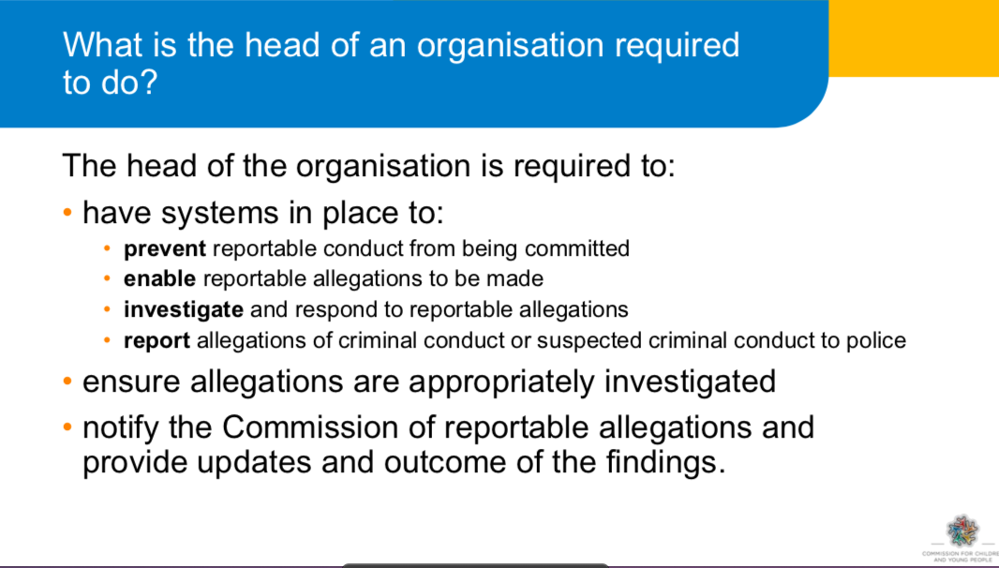

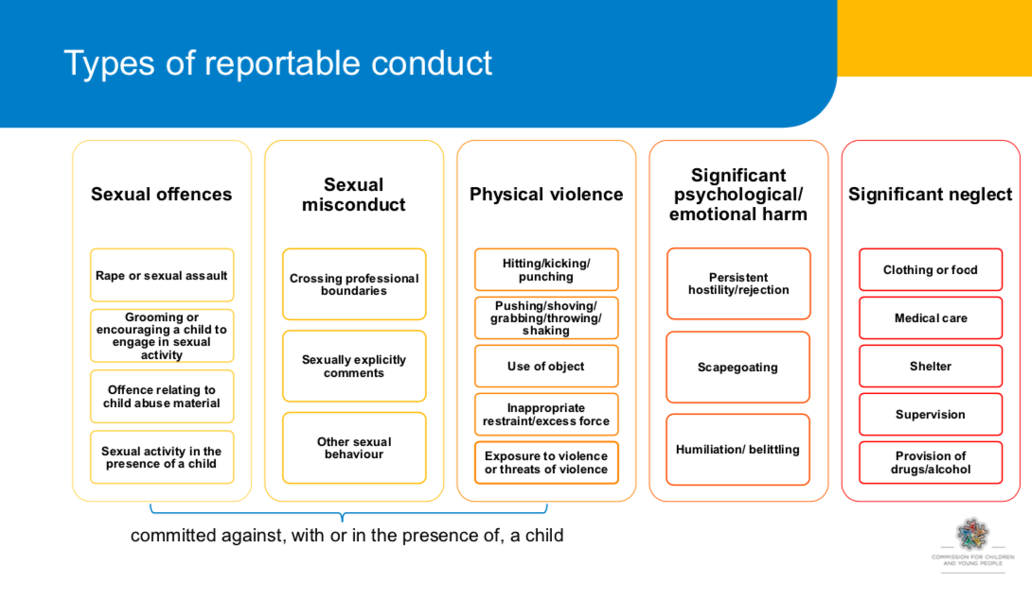

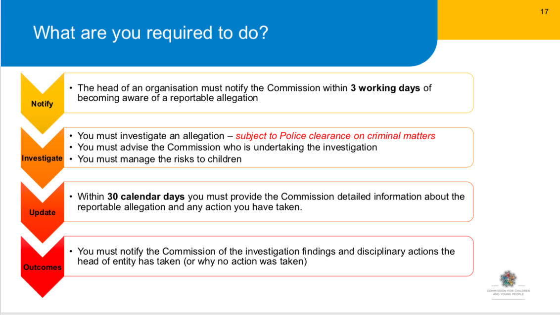

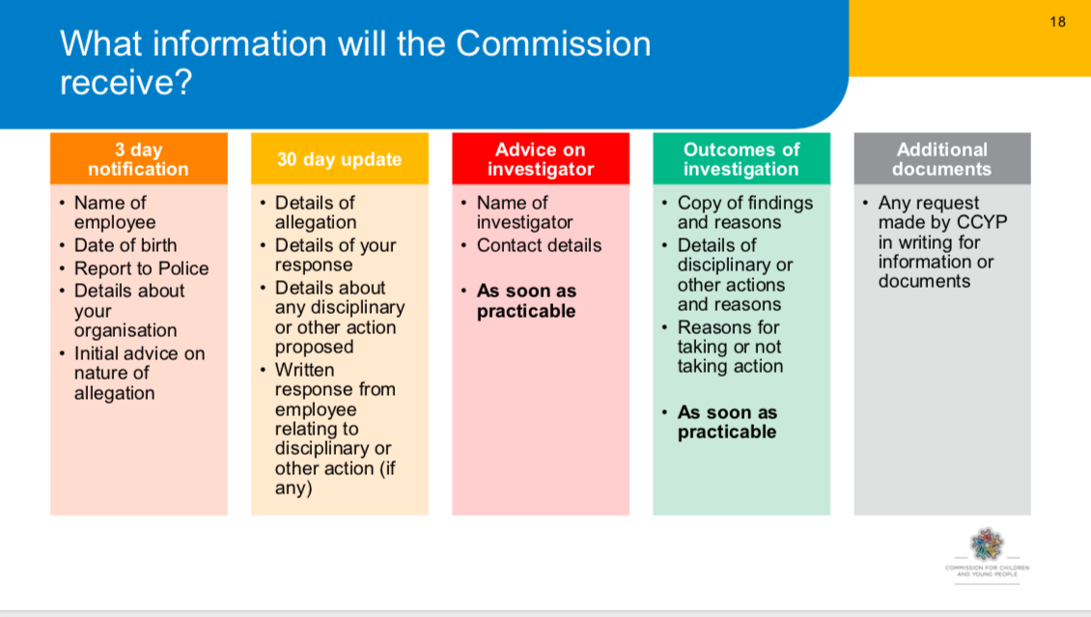

A more complete outline of the elements of the Reportable Conduct Scheme can be found at:

<https://ccyp.vic.gov.au/child-safety/resources/reportable-conduct-scheme-information-sheets/>

**APPENDIX 5 INCIDENT REPORTING FORM**

Please use the Form to report an Incident. **Please read the Code of Conduct Document before using this form.**

**When should this report be completed?**

This report must be completed if:

1. An outside emergency service is contacted (Police, Ambulance, State Emergency Service etc.).
2. An individual is taken to hospital, doctor’s surgery, emergency dental surgery, or other medical professional.
3. An injury results in a participant being unable to participate for 24 hours.
4. There is an alleged illegal act, a participant sent home, serious leader dispute, damage or loss of property.
5. Other situations will require judgement and consultation with your organisation. In situations where doubt exists about the use of this report, complete a report.

**How do I complete this report:**

* Sections A, B & D must be completed in all situations.
* Section C is to be completed where there is an injury to an individual.

**What do I do with this report after I have completed it?**

1. Check that all information is correct to the best of your knowledge.
2. Check that the appropriate signatures are given.
3. The Team Leader forwards the form to your Coordinator as soon as possible. More severe incidents require immediate reporting, while other reports should be submitted within seven days.

The **Incident Form** can be downloaded using this link: [Link to Forms](https://safechurchcrca.org.au/safe-church-documents/4-forms) (https://safechurchcrca.org.au/safe-church-documents/4-forms)

**APPENDIX 6 Definitions of Abuse against Children**

**Child abuse includes:**

Any act committed against a child involving

1. a sexual offence; or
2. an offence under section 498(2) of the Crimes Act 1958 (grooming); and
3. the infliction, on a child, of-
   * 1. physical violence; or
     2. serious emotional or psychological harm; and
4. serious neglect of a child.

“Child” means a person under the age of 18 years unless otherwise stated under the law applicable to the child. Collective term for “child” is “children”.

There are five common types of abuse: physical, sexual, emotional, neglect and racial/cultural

1. **Physical Abuse**

Physical abuse is any non-accidental physical injury resulting from practices such as:

* Hitting, punching, kicking, beating (marks from belt buckles, fingers).
* Shaking (particularly babies).
* Burning (irons, cigarettes), biting, pulling out hair.
* Alcohol or other drug administration.
* Fractured bones – especially in young children.
* Strangulation.
* Unexplained or hidden injuries.

1. **Sexual Abuse, including ‘grooming’**

**Sexual abuse** is any sexual act or threat to perform such upon another person. It occurs when a person uses their power and authority to take advantage of another’s trust to involve them in sexual activity. It does not necessarily involve genital contact but is any act which erodes the sexual boundary between two persons. It may appear consensual but the validity of consent is negated by the power differential.

**Sexual grooming** is a pattern of behaviour aimed at engaging a child, as a precursor to sexual abuse. Examples include inappropriate special time with the child, inappropriately giving gifts, ‘accidental touching’, allowing the child to sit on lap, having secrets. In isolation, such behaviours may not indicate the risk of abuse occurring, but if there is a pattern of behaviour occurring, it may indicate grooming. Grooming behaviours often mimic the kind of relationship-developing strategies that Christian ministries use for the benefit and wellbeing of children, that is, gaining the trust of the child, demonstrating care and concern, spending time, visiting in the home, finding out about family, friends and hobbies. However, grooming to involve a child in sexual activities for the personal gratification of an adult is a crime. The grooming process often starts with the person ‘grooming’ the organization or church by building trust. Then progressively the perpetrator starts to target families before starting to groom the child.

1. **Emotional or Psychological Abuse**

Emotional abuse is the chronic attitude or behaviour of one person, which is directed at another person, or, the creation of an emotional environment which erodes a child’s development, self-esteem and social confidence over time. Behaviours may include: devaluing, ignoring, rejecting, corrupting, isolating, terrorising or chronic and extreme domestic violence in the child’s presence.

1. **Neglect**

Neglect is characterised by the failure to provide for the child’s basic needs. It includes any serious omission or commission which jeopardises or impairs a person’s development. Examples include the failure to provide food, shelter, healthcare, adequate hygiene or schooling for a child.

1. **Bullying and cyber-bullying**

Bullying can be defined as repeated, unreasonable, unwanted behaviour conducted by an individual or group against another person, which has a negative impact on health and wellbeing. This includes aggression, verbal, emotional/psychological or physical acts or the use of social media or other forms of communication that intimidates, humiliates or threatens. It often involves an abuse of a power differential between the bully and the victim.

Cyber-bullying occurs when a person uses any form of telecommunication to sexually groom, bully, suggest an inappropriate relationship be formed, or engage a child in sexual language or behaviours. The explosion of electronic communications (Facebook and other social media sites, text-messaging, internet chat rooms etc.) has seen a sharp increase in cyber-bullying. Appendix 11 contains <church>’s electronic communication policy.

1. **Other abuse**

We recognise that abuse can also take many other forms, and we commit to treating all children and young people with respect, fairness, compassion and encouragement, regardless of any differences.

**APPENDIX 7 (Example) Feedback Survey of Children. Name:_________________**

This survey is your chance to have a say about the children’s programs. Think about each statement and mark on the line, somewhere between “Not at all!’ and ‘Absolutely!’.

1. **I feel welcomed and looked after when I come to this church..**

I__________________________________I_____________________________________I

Not at all. Mostly Absolutely!

1. **My parents like and follow the log-in process and arrangements for my care.**

I__________________________________I_____________________________________I

Not at all. Mostly Absolutely!

1. **I know which toilets to use and feel safe when using them.**

I__________________________________I_____________________________________I

Not at all. Mostly Absolutely!

1. **There are good spaces for activities and learning times.**

I__________________________________I_____________________________________I

Not at all. Mostly Absolutely!

1. **The activities are fun, challenging and well-organised.**

I__________________________________I_____________________________________I

Not at all. Mostly Absolutely!

1. **I feel safe and relaxed while I am in the children’s programs.**

I__________________________________I_____________________________________I

Not at all. Mostly Absolutely!

1. **I feel that the leaders know what they are doing and are looking after me.**

I__________________________________I_____________________________________I

Not at all. Mostly Absolutely!

1. **The leaders are friendly and respectful of my friends and me.**

I__________________________________I_____________________________________I

Not at all. Mostly Absolutely!

1. **If I am worried or upset, I know who I can go to for help.**

I_______________________________I___________________________________I

Not at all. Mostly Absolutely!

1. **I would recommend this church program as great for kids.**

I________________________________I___________________________________I

Not at all. Mostly Absolutely!

Appendix 8 – Alternative to ChildSafe CSE3-MF Form

MEDICAL & HEALTH INFORMATION – SPECIAL EVENT (EXAMPLE)

…………………………….…………………**(**Insert organisation name)**

Child’s Name:

(Surname) (Christian name) Date of Birth

Is your child taking any regular or currently prescribed medication? YES / NO

If so, please name the medication and provide details of dosage and administration.

Your child’s leader will administer medication to your child as directed by written instructions from you. Please clearly mark your child’s name on all medication along with the dosage and administration procedures.

Is there anything about your child’s health which means that s/he should engage in only limited physical activity? YES / NO

If so, please give details

Does your child require a special diet because of health problems? YES / NO

If so, please give details

Is there any other information which may help us care for your child? YES / NO

If so, please give details

Emergency contact 1. Name: ___________________________________ Mobile: _______________________

Emergency contact 2. Name: __________________________________ Mobile: _______________________

Preferred Medical Centre/ Doctor: ______________________________________ Phone: ________________

Do you have private medical insurance? Provider: ________________________________________________

**AUTHORISATION**

‘In the event of an accident or sudden illness, I authorise the person in charge to call an ambulance or to seek medical attention at my expense, should I not be contactable.’

Signed: ______________________________________________ Date: ___/____/20___

Parent/guardian/caregiver [Print name if not one of the above] _______________________________

Witness Name: _______________________________ Signature: _____________________________________

Appendix 9 Example Permission Form – Alternative to ChildSafe CSE3-RR

PERMISSION TO ATTEND EVENT/CAMP FORM (EXAMPLE)

…………………………….…………………**(**Insert organisation name)**

As a parent/caregiver of:

I, give my consent for him/her to take

part in the <special activity or camp> to be held at the (event site)

from to (or on )

*(date) (date) (date)*

I have seen the attached copy of the programme for the (event)

and acknowledge that risk of injuries is inherent in physical activities. While I am aware that staff will take all due care, I recognize that accidents may occur.

The staff and supervisors have my authority to take whatever action they think necessary to ensure the safety, wellbeing and successful conduct of the participants as a group or individually in the above-mentioned activity.

If my child becomes ill or is accidentally injured, I authorise the person-in-charge to obtain on my behalf whatever medical treatment my child requires. I will agree to pay all such medical expenses.

I have attached information as asked concerning my child’s health including any relevant details of his/her limitations for the planned activity. My child’s own local doctor or medical specialist may be contacted in an emergency.

I also acknowledge that the <Church> and all its representative leaders or other helpers at <name of event> can accept no liability for any personal injury or property loss suffered by my child during the period of the <name of event>.

Signed: __________________________________________________ Date:___/____/20___ Parent/Guardian/Care-giver

Appendix 10 MINISTRY/ORGANISATIONAL COVENANT

**Of <Church>**

I, ______________________________________________

(Print name)

1. Declare that, except as is stated below,

(1) have not been guilty of any sexual misconduct against any person;

(2) have never committed any criminal offence involving fraud, violence or drugs;

(3) am of good character and suitable for ministry within **<Church>**.

(If exceptions to the above give details and if insufficient room place them in an attachment).

2. Acknowledge I have read and agreed to the <church’s> Child Protection Policies, Code of Conduct and the ChildSafe Team Member Guide.

1. Agree I will cooperate with the **<Church>** in any investigation undertaken in relation to a complaint or allegation of impropriety or misconduct made against me.
2. Agree I will attend and take part in education courses to prepare and equip me for ministry with children.
3. Acknowledge that by signing this covenant no legal contract is created between myself and my **<Church>** but accept that it acts as a consent for the operation of the Child Protection Policy and the Child Protection Procedure Manual and that legal consequences may follow if I have knowingly given false answers to any of the questions 1 – 4 above.

Signature: Witness:

Full name: Name:

Address:……………………………………………………………………………………… Date: ………………………………..

**APPENDIX 11 ELECTRONIC COMMUNICATIONS**

**Aim**

This Policy seeks to outline guidelines and good practice for youth leaders in using electronic communication tools in a safe and encouraging way for those under the church’s care.

# Online and smart phone usage guidelines

### **For people in ministry roles**

The following guidelines are to assist all people who work with young people and all people who are in positions of authority within the CRCA. Where the phrase “young person” or “young people” is used it is always defined as a person or people under 18 years of age. This advice provides useful general guidance in regard to online and smart phone communication (i.e. all electronic communication).  In cases where ministry outcomes are in part effected through the use of social media then it is recommended that particular practice guidelines pertaining to that ministry are developed and clearly communicated to the leaders. The SCU is available for assistance in establishing such particular guidelines.

### **Safe Church**

The Safe Church Code of Conduct states that: “This **Code of Conduct** seeks to apply to the ministerial, or pastoral relationship those ethical standards that God expects of all people. People in various forms of recognised ministry are therefore expected to be examples and models of Christian faith and practice. It is the duty of any person in a ministry position not to use the influence or authority of their position for personal gain, whether that gain is financial or in terms of power, sexual gratification, or otherwise. This includes any action, verbal, written or electronic, physical or emotional that could be interpreted as emotional, sexual or spiritual abuse, and applies especially when working with children. We recognize the power differential between children and adults in ministry roles, and these guidelines seek to ensure that such a power is not used to harm children or any vulnerable person.”  This point has application to your use of all electronic communications as a person of authority or person working with young people in the CRCA.

### **Basic Principles**

There are three basic principles when having any type of conversation with a young person:

1. Remember God is listening: • The ‘God test’ – is this conversation honouring God? • The ‘parent test’ – if this young person’s parents were listening/reading this, would they feel comfortable with this conversation?
2. Seek transparency in conversations with young people and do not converse where you can’t be observed by others.
3. Don’t get in deeper than you can handle – if issues arise that are greater than your ability or in an area of your weakness refer the young person to others who are better equipped to deal with it. When in doubt, ask for help

Online and smart phone communications can create an intense, relational situation because of the ease of access, the comfort of distance and its unobserved nature. A relationship can be developed far more quickly than was possible before online communication was common. Therefore, the church considers talking with young people online and via smart phone to be exactly the same as talking to them face to face. The same code of conduct for leaders interacting with young people face to face applies to all types of online and smart phone communication.

### **Specific conduct guidelines:**

Facebook/Twitter/Instagram/blogs/websites

If your church ministry or organisation establishes any of the above social media platforms as a method of communication within the group this is the best place for leaders to converse with members of the group as all conversations may be held in public. Ensure there is no option for private conversations to take place on this facility.

Best practice is for leaders not to be individual friends on social media with young people within the church or organisation. This is due to the risks inherent in private relationships which may develop over social media. These risks affect both young people and leaders.

However it is recognised that leaders may be individual friends on social media with young people where the relationship is pre-existing or established via other connections, for example they may be related or may have formed the friendship via knowing each other external to the leader/group member relationship. In circumstances where leaders are individual friends with young people on social media leaders are at all times to adhere to the basic principles above. 

SMS Text messaging/emails

Best practice is to only use the above methods of communication as a “one-way” avenue for communicating within the group. Make it clear to all members of the group that while SMS texts/emails will be used for communication leaders will not reply individually to any response from group members, unless a matter of urgency arises and in every case, with a fellow leader copied in on the reply. Give parents the option of always being copied in on any communication from the ministry or organisation leaders and add those parents to the contacts list.  When sending group emails always remember to send any email to yourself first and put all contacts into the blind copy (BCC) field to ensure you do not distribute email addresses without permission. Always copy in fellow leaders. Follow the same privacy protocols if using SMS texts to do mass communication within the group.

Phone/Skype/Zoom/FaceTime/Messaging Apps/In-game messaging

In the main seek to avoid where possible individual contact with young people via online and smart phone communication. Aim to have 100% of communication to young people via group communication. Should a need arise to use phone/Skype/FaceTime/Zoom you should be accountable – always get parental permission before you talk with a young person over the phone and tell a co-leader that you are conversing with a young person by phone. If using Skype, Zoom or FaceTime again always get parental permission before you talk with a young person using this facility. Ensure both you and the young person are using this form of communication in an open area where people can see you or there are others present, e.g. not alone in your room. Do not use Messaging Apps or in-game messaging to communicate individually with children or people under your pastoral care in your Church role.  
   
In the case where an inappropriate message or image is sent to a leader by a child or a person under pastoral care/leadership via any online or smart phone communication, whether publicly or privately, the leader should not reply under any circumstances. Do not delete the image or message. The leader must immediately notify the ministry or organisation leader that this has occurred. The ministry or organisation leader may then contact the SCU for advice on how to proceed.

Cyber bullying and image based abuse

Sadly, there is an increase in the prevalence of cyber bullying and image based abuse targeting both adults and children in Australia, mostly via social media. Both State and Federal parliaments have begun to address this societal problem through legislation and the provision of assistance to Australians via the Office of e-safety – [www.esafety.gov.au](https://www.esafety.gov.au/)  If you become aware of cyber bullying or image based abuse within the church context visit [www.esafety.gov.au](https://www.esafety.gov.au/) and contact SCU for assistance and reporting.

**APPENDIX 12 TRANSPORT**

**Who can transport participants?**

To transport participants, you must:

* Have P2 green probationary or an open license. You cannot transport participants if you have a Learners permit or a P1 red probationary license.
* You must have a good driving record.
* Inform and obtain approval from the Team Leader in charge of the relevant activity prior to the trip.
* Completed the form ‘CSE3-DD Drivers Declaration’

**Vehicle requirements**

All vehicles used to transport people during a program must be roadworthy and have current registration. It is the responsibility of the driver to ensure that the vehicle is safe for use. You should use the following POWER checklist:

**P**etrol – plenty of fuel.  
**O**il – correct level.  
**W**ater – correct level.  
**E**lectrics – all lights, indicators and other devices are functional.  
**R**ubber – tyres are in good condition and correctly inflated

**Guidelines when transporting participants:**

* Parental/ guardian permission should be obtained before transporting participants under the age of 18.
* There should always be another person in the car, preferably another Team Member.
* It is preferable to transport a participant of the same gender rather than of the opposite gender to yourself.
* Transport should only be provided for organised events where the relevant permissions have been granted or when permission has been granted by the Team Leader

**Family and Friends Transport**

It is recommended that you follow our transport policy even for friends and family as these guidelines provide protection for both the Team Member and the Participant. However, we do understand that this situation arises at times amongst close friends and relatives. If you choose to transport family and friends, you are doing so against our transport policy and do so at your own risk, a few things you should consider are:

* Plan your trip not to be alone with a child under 18, try to take a sibling or friend with you.
* For your protection never offer a lift, if asked to transport a child, take someone with you or try to make alternate arrangements.
* If you do transport family or friends always make personal contact with the parent/guardian on arrival.
* For your protection take and keep a personal note of the trip, including the specific times of arrival and departure, and any relevant issues or topics of discussion.
* If you are a young person transporting your personal friends, always ensure that their parent is aware that you are transporting them.

1. It is recognized that no organisation can guarantee the safety of children and other vulnerable people who are on site at a venue. The term ‘child-safe’ means that child safety is paramount to this organisation, that it has compliant policies and procedural documents and that risk identification and mitigation practices are embedded in the culture.
2. The governing body is the leadership group of your community. It might be called the Board, Eldership, Church Council or another title. This is the legal entity responsible for determining culture and approving policies.
3. This may be a function of the Board or Committee of Management, rather than a separate group. If so, there should be a standard Agenda item re Risk Management in meetings.
4. It is important to have an arrangement in place. The investigator must be a person of experience and qualification, maybe with a role in the wider church association or sourced through GJIC Insurance.