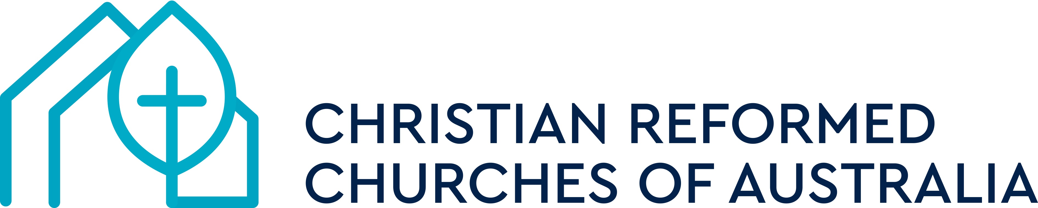
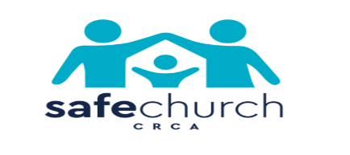
SAFE CHURCH UNIT FACILITATOR

The Synod of the Christian Reformed Churches of Australia is committed to facilitating the safety of all children and vulnerable people in their congregations and other activities conducted on its behalf.
At the Synod in May 2022, the Safe Church Unit was approved, including the appointment of a Safe Church Facilitator. We thank God for His provision are delighted to announce that Daniele Donnini and team through his company Align TSC have been appointed in this role. Daniele started in the role in January 2023.

Daniele and the Align TSC team come with outstanding qualifications and a lot of experience in Safeguarding. Daniele has experience working with vulnerable children and families, delivering services to vulnerable people in both state government and NGOs. Daniele has extensive experience in senior management, program delivery, policy development and emergency services, with contextual safeguarding experience within organizations and faith communities. Most recently Daniele has been the National Director of Safeguarding and Improvement for the Catholic Church in Australia, where for the last several years he led the Catholic Church’s National Safeguarding approaches. Daniele and the Align TSC team have formal qualifications which underpin their extensive experience, in the areas of Community Services; Management; Education (Specializing in Safeguarding); Counseling, Clinical support, Supervision, Divinity and Research Methodologies.

Daniele and the Align TSC team may be contacted via email at scu@crca.org.au or by phone
on 0477 677 799.
More information about the Safe Church Unit is available in the SCU Mandate.
Here is a link: https://safechurchcrca.org.au/safe-church-documents/36-scu-mandate-v1/viewdocument/36

With the appointment of Daniele and his team, John Van Dijk’s role as Interim Safe Church Facilitator comes to an end. We thank John for the development of the SCU and the work in recent months. John will now concentrate on his role as National ChildSafe Administrator and as vice-chairman of the Safe Church Advisory Committee.

We would also like to take the opportunity to thank Rev Dr Leo Douma for his excellent and lengthy leadership of the Safe Church Advisory Committee (previously known as NSACC). Due to ill health Leo resigned as chairman and at the Committee meeting last week, Peter Abetz was elected chairman.

Peter Abetz
Chairman SCAC

